# Body size and early marine conditions drive changes in Chinook salmon productivity across northern latitude ecosystems

**Authors:** Megan L. Feddern1, Rebecca Shaftel2,3,4, Erik R. Schoen5, Curry J. Cunningham1, Brendan M. Connors6, Benjamin Staton7, Al von Finster8, Zachary Liller9, Vanessa R. von Biela10, Katherine G. Howard9

1. University of Alaska Fairbanks, College of Fisheries and Ocean Sciences, 17101 Point Lena Loop Road, Juneau Alaska

2. University of Alaska Fairbanks, College of Fisheries and Ocean Sciences, Fairbanks Alaska

3. Alaska Center for Conservation Science, University of Alaska Anchorage, Anchorage, AK

4. BLM Alaska, Anchorage, AK

5. International Arctic Research Center, University of Alaska Fairbanks, Fairbanks, AK, USA

6. Institute of Ocean Sciences, Fisheries and Oceans Canada, Sidney, British Columbia, Canada

7. Columbia River Inter-Tribal Fish Commission, Portland, OR, USA

8. Fisheries and Oceans Canada, Whitehorse, Yukon Y1A 2T9, Canada; Retired

9. Alaska Department of Fish and Game, 333 Raspberry Rd, Anchorage, AK 99518, USA

10. U.S. Geological Survey, Alaska Science Center, 4210 University Drive, Anchorage, AK

**Corresponding Author:** Megan L. Feddern, [megan.feddern@noaa.gov](mailto:mfeddern@alaska.edu)

Appendix S1: Spawner and Recruit Data Sources 4

Table S1. Data Sources 4

Figure S1. Spawning Abundance Time Series 9

Figure S2. Recruitment versus Spawning Abundance 10

Figure S3. Productivity versus Spawner Abundance 11

Appendix S2: Model estimates with simulated data 14

Table S3. Simulated Models 17

Figure S4. Simulated Non-linear Relationships 18

Figure S5. Simulated Error Results 19

Figure S6. Simulated Null Covariate Results 20

Appendix S3: Dynamic factor analysis to combine covariate data 21

Figure S7. DFA Size Latent Trend and Loadings (Kuskokwim) 23

Figure S8. DFA Size Model Fits (Kuskokwim) 24

Figure S9. DFA Size Latent Trend and Loadings (Yukon) 25

Figure S10. DFA Size Model Fits (Yukon) 26

Figure S11. DFA Marine Competitor Latent Trend and Loadings 27

Figure S12. DFA Marine Competitor Model Fits 28

Appendix S4: Freshwater covariate processing 30

Figure S13. Mainstem Maximum Daily Stream Temperatures 33

Appendix S5: Covariate Selection and Multicollinearity 36

Table S4. Candidate Covariate Datasets 37

Table S5. Variance Inflation Factors 43

Table S6. Density Dependent Effect Sizes 44

Table S7. Covariate Effect Size 46

Figure S14. Correlation Plot Candidate Freshwater Covariates 48

Figure S15. Correlation Plot Candidate Marine Covariates 49

Figure S16. Correlation Plot Final Model Covariates (lagged) 50

Figure S17. Correlation Plot Final Model Covariates (unlagged) 51

Appendix S6: Model fits 52

Figure S18. Model Fits 52

Figure S19. Sensitivity Test for Body Size 53

Figure S20. Sensitivity Test for Marine Competitors 54

Figure S21. Non-linear Test 55

# **Appendix S1:** Spawner and Recruit Data Sources

## Table S1. Data Sources

Description of spawner-recruit data sources for each population unit used for the analysis. Data were available for each population unit in the Kuskokwim region from 1976 - 2013 but were truncated to exclude years without direct observations of spawning abundance for a given population unit (see Staton et al. 2020). Time series source refers to the source of time series data used in the model, data source refers to the sources of data used to generate the time series.

|  |  |  |  |  |
| --- | --- | --- | --- | --- |
| Population Unit | Region | Model  *Time Series Source* | Time Series  (Brood Year) | Data Source |
| Aniak River | Kuskokwim | State-space (SSM-VM)  *Staton et al. 2020* | 1983 - 2013  N = 31 | Liller et al. 2018; Schaberg et al. 2012; Smith and Liller 2017a; 2017b; Stuby 2007 |
| George River | Kuskokwim | State-space (SSM-VM)  *Staton et al. 2020* | 1996 - 2013  N = 18 | Liller et al. 2018; Schaberg et al. 2012; Smith and Liller 2017a; 2017b; Stuby 2007 |
| Goodnews Middle Fork | Kuskokwim | Regression  *This study using methods from Taylor and Elison 2009 and data from Froning and Smith 2020* | 1991 - 2009  N = 19 | Taylor and Elison 2009;  Froning and Smith 2020 |
| Holitna River | Kuskokwim | State-space (SSM-VM)  *Staton et al. 2020* | 1980 - 2013  N = 34 | Liller et al. 2018; Schaberg et al. 2012; Smith and Liller 2017a; 2017b; Stuby 2007 |
| Holokuk River | Kuskokwim | State-space (SSM-VM)  *Staton et al. 2020* | 1993 - 2013  N = 21 | Liller et al. 2018; Schaberg et al. 2012; Smith and Liller 2017a; 2017b; Stuby 2007 |
| Kisaralik River | Kuskokwim | State-space (SSM-VM)  *Staton et al. 2020* | 1980 - 2013  N = 34 | Liller et al. 2018; Schaberg et al. 2012; Smith and Liller 2017a; 2017b; Stuby 2007 |
| Kogrukluk River | Kuskokwim | State-space (SSM-VM)  *Staton et al. 2020* | 1980 - 2013  N = 34 | Liller et al. 2018; Schaberg et al. 2012; Smith and Liller 2017a; 2017b; Stuby 2007 |
| Kwethluk River | Kuskokwim | State-space (SSM-VM)  *Staton et al. 2020* | 1992 - 2013  N = 22 | Liller et al. 2018; Schaberg et al. 2012; Smith and Liller 2017a; 2017b; Stuby 2007 |
| Oskawalik River | Kuskokwim | State-space (SSM-VM)  *Staton et al. 2020* | 1987 - 2013  N = 27 | Liller et al. 2018; Schaberg et al. 2012; Smith and Liller 2017a; 2017b; Stuby 2007 |
| Pitka Fork | Kuskokwim | State-space (SSM-VM)  *Staton et al. 2020* | 2000 - 2013  N = 14 | Liller et al. 2018; Schaberg et al. 2012; Smith and Liller 2017a; 2017b; Stuby 2007 |
| Swift River | Kuskokwim | State-space (SSM-VM)  *Staton et al. 2020* | 1980 - 2013  N = 34 | Liller et al. 2018; Schaberg et al. 2012; Smith and Liller 2017a; 2017b; Stuby 2007 |
| Takotna River | Kuskokwim | State-space (SSM-VM)  *Staton et al. 2020* | 1996 - 2013  N = 18 | Liller et al. 2018; Schaberg et al. 2012; Smith and Liller 2017a; 2017b; Stuby 2007 |
| Tatlawiksuk River | Kuskokwim | State-space (SSM-VM)  *Staton et al. 2020* | 1999 - 2013  N = 15 | Liller et al. 2018; Schaberg et al. 2012; Smith and Liller 2017a; 2017b; Stuby 2007 |
| Tuluksak River | Kuskokwim | State-space (SSM-VM)  *Staton et al. 2020* | 1991 - 2013  N = 23 | Liller et al. 2018; Schaberg et al. 2012; Smith and Liller 2017a; 2017b; Stuby 2007 |
| Andreafsky East Fork | Yukon (US) | Regression  *Brown et al. 2020* | 1994 - 2010  N = 17 | Siegel 2017; Fleischman and Evenson 2010 |
| Chena River | Yukon (US) | State-space  *Joy and Tyers in review* | 1986 - 2016  N = 31 | Joy and Tyers in review |
| Gisasa River | Yukon (US) | Regression  *Brown et al. 2020* | 1995 - 2010  N = 16 | Siegel 2017; Fleischman and Evenson 2010 |
| Salcha River | Yukon (US) | State-space  *Joy and Tyers in review* | 1987 - 2016  N = 30 | Joy and Tyers in review |
| Yukon Lower Mainstem | Yukon (CA) | State-space  *Connors et al. 2022* | 1985 - 2015  N = 31 | JTC 2021; Beacham et al., 2006; Beacham et al., 2018; DFO 2018 |
| Yukon Middle Mainstem | Yukon (CA) | State-space  *Connors et al. 2022* | 1985 - 2015  N = 31 | JTC 2021; Beacham et al., 2006; Beacham et al., 2018; DFO 2018 |
| Teslin Population Unit | Yukon (CA) | State-space  *Connors et al. 2022* | 1985 - 2015  N = 31 | JTC 2021; Beacham et al., 2006; Beacham et al., 2018; DFO 2018 |
| Upper Mainstem Population Unit | Yukon (CA) | State-space  *Connors et al. 2022* | 1985 - 2015  N = 31 | JTC 2021; Beacham et al., 2006; Beacham et al., 2018; DFO 2018 |
| Carmacks Population Unit | Yukon (CA) | State-space  *Connors et al. 2022* | 1985 - 2015  N = 31 | JTC 2021; Beacham et al., 2006; Beacham et al., 2018; DFO 2018 |
| Pelly Population Unit | Yukon (CA) | State-space  *Connors et al. 2022* | 1985 - 2015  N = 31 | JTC 2021; Beacham et al., 2006; Beacham et al., 2018; DFO 2018 |
| Stewart Population Unit | Yukon (CA) | State-space  *Connors et al. 2022* | 1985 - 2015  N = 31 | JTC 2021; Beacham et al., 2006; Beacham et al., 2018; DFO 2018 |
| White-Donjek Population Unit | Yukon (CA) | State-space  *Connors et al. 2022* | 1985 - 2015  N = 31 | JTC 2021; Beacham et al., 2006; Beacham et al., 2018; DFO 2018 |

Table S2. Assumptions for Data Sources

Summary of assumptions used in each time series source. Additional details can be found in each data source.

|  |  |  |
| --- | --- | --- |
| **Assumption Type** | **Description** | **Time Series Sources** |
| Exploitation Rate | Each population had the same exploitation rate as aggregate exploitation rate across all Canadian Yukon stocks | Connors et al. 2022 |
| Exploitation Rate | Same proportion of fish were harvested from the middle fork relative to the mainstem as escaped to the middle fork relative to the mainstem | Taylor and Elison 2009, Froning and Smith 2020 |
| Exploitation Rate | Each population had the same exploitation rate as drainage (mainstem) exploitation rate | Staton et al. 2020; Brown et al. 2020 |
| Age Composition | Age comps were based on aggregate at US/CA border prior to 2008 and population specific observations thereafter | Connors et al. 2022 |
| Age Composition | Age composition of harvest is the same as escapement | Joy and Tyers in review, Connors et al. 2022, Staton et al. 2020 |
| Maturation | Age-at-maturity varies by brood year but is shared by all populations | Connors et al. 2022, Staton et al. 2020 |
| Survey Type | Aerial surveys were expanded based on paired aerial survey-weir projects | Staton et al. 2020 |

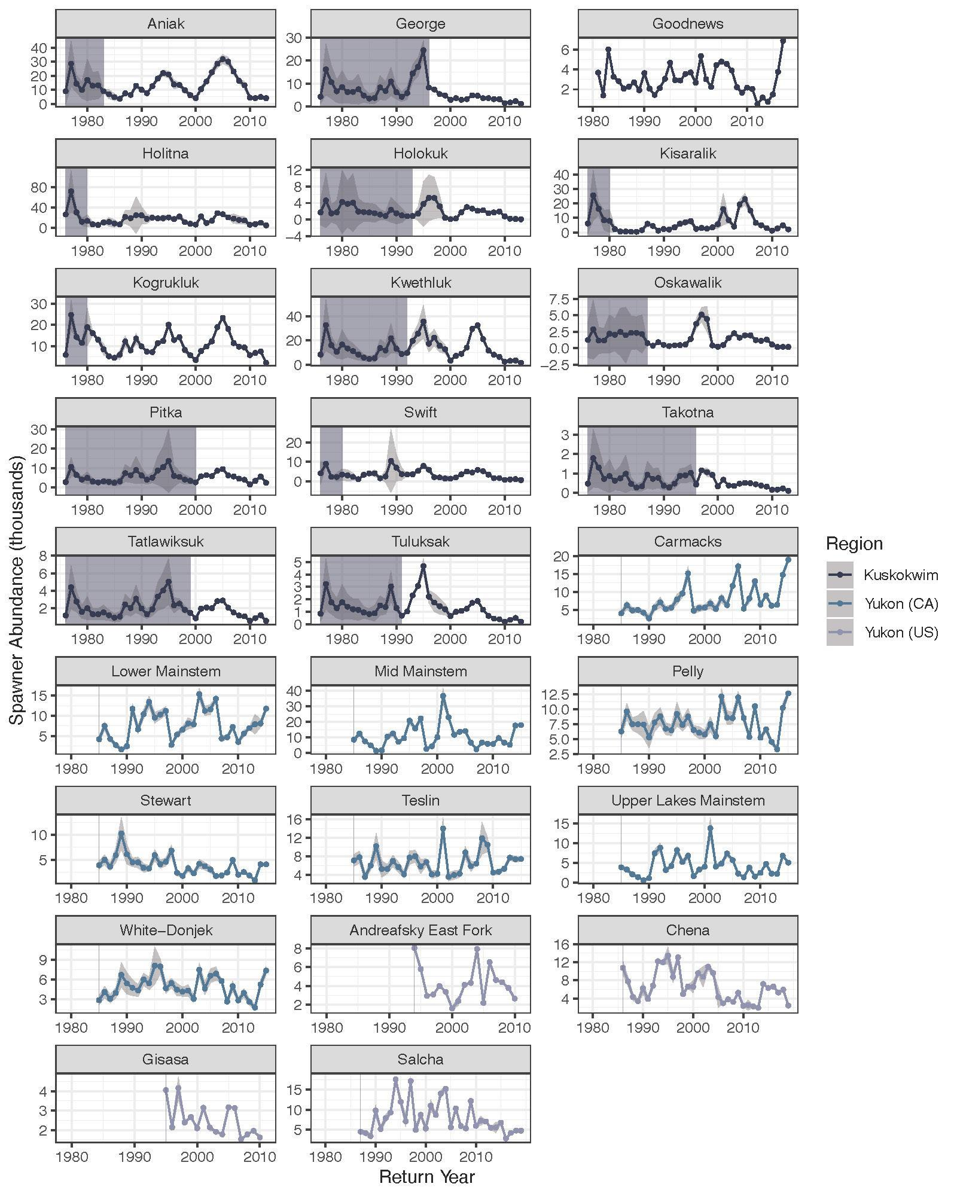

## Figure S1. Spawning Abundance Time Series

Estimated spawning abundance of each Chinook salmon population unit for all available years in which full returns have been observed. Y-axes and X-axes are scaled differently for each population. Shaded box indicates years that were omitted from the model due to lack of spawner data or missing years in covariate time series, shaded ribbon denotes +/- 1 SD.

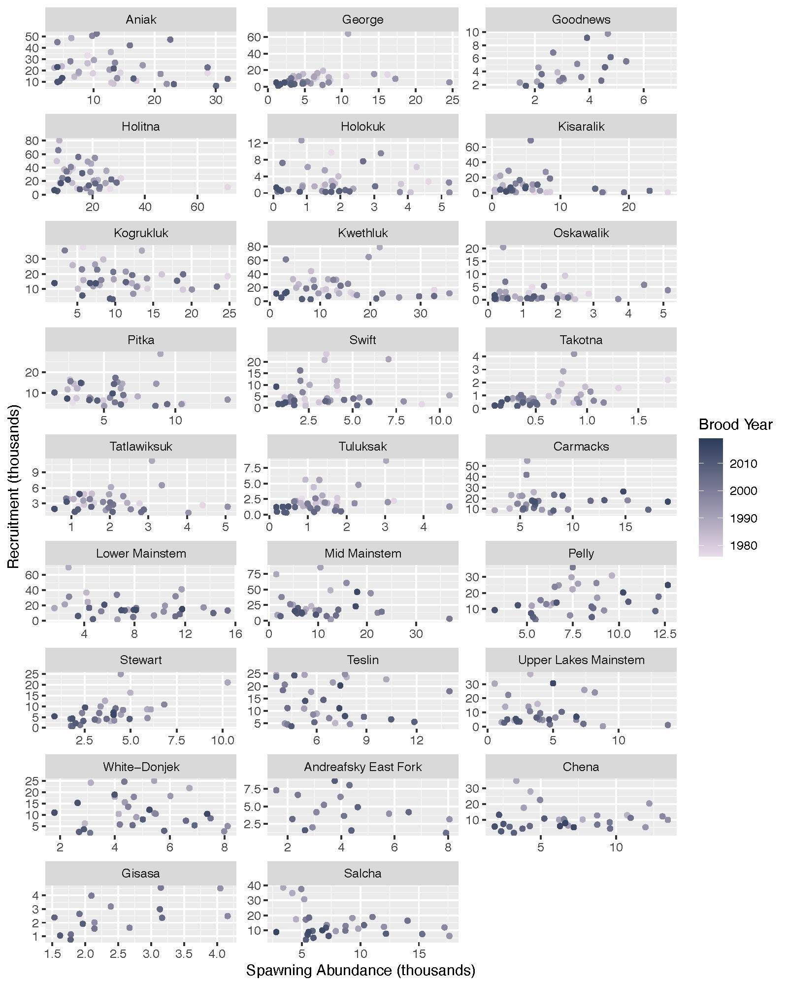

## Figure S2. Recruitment versus Spawning Abundance

Recruitment as a function of spawning abundance for all available data. Each data point represents one brood year for one population for years in which full returns have been observed.

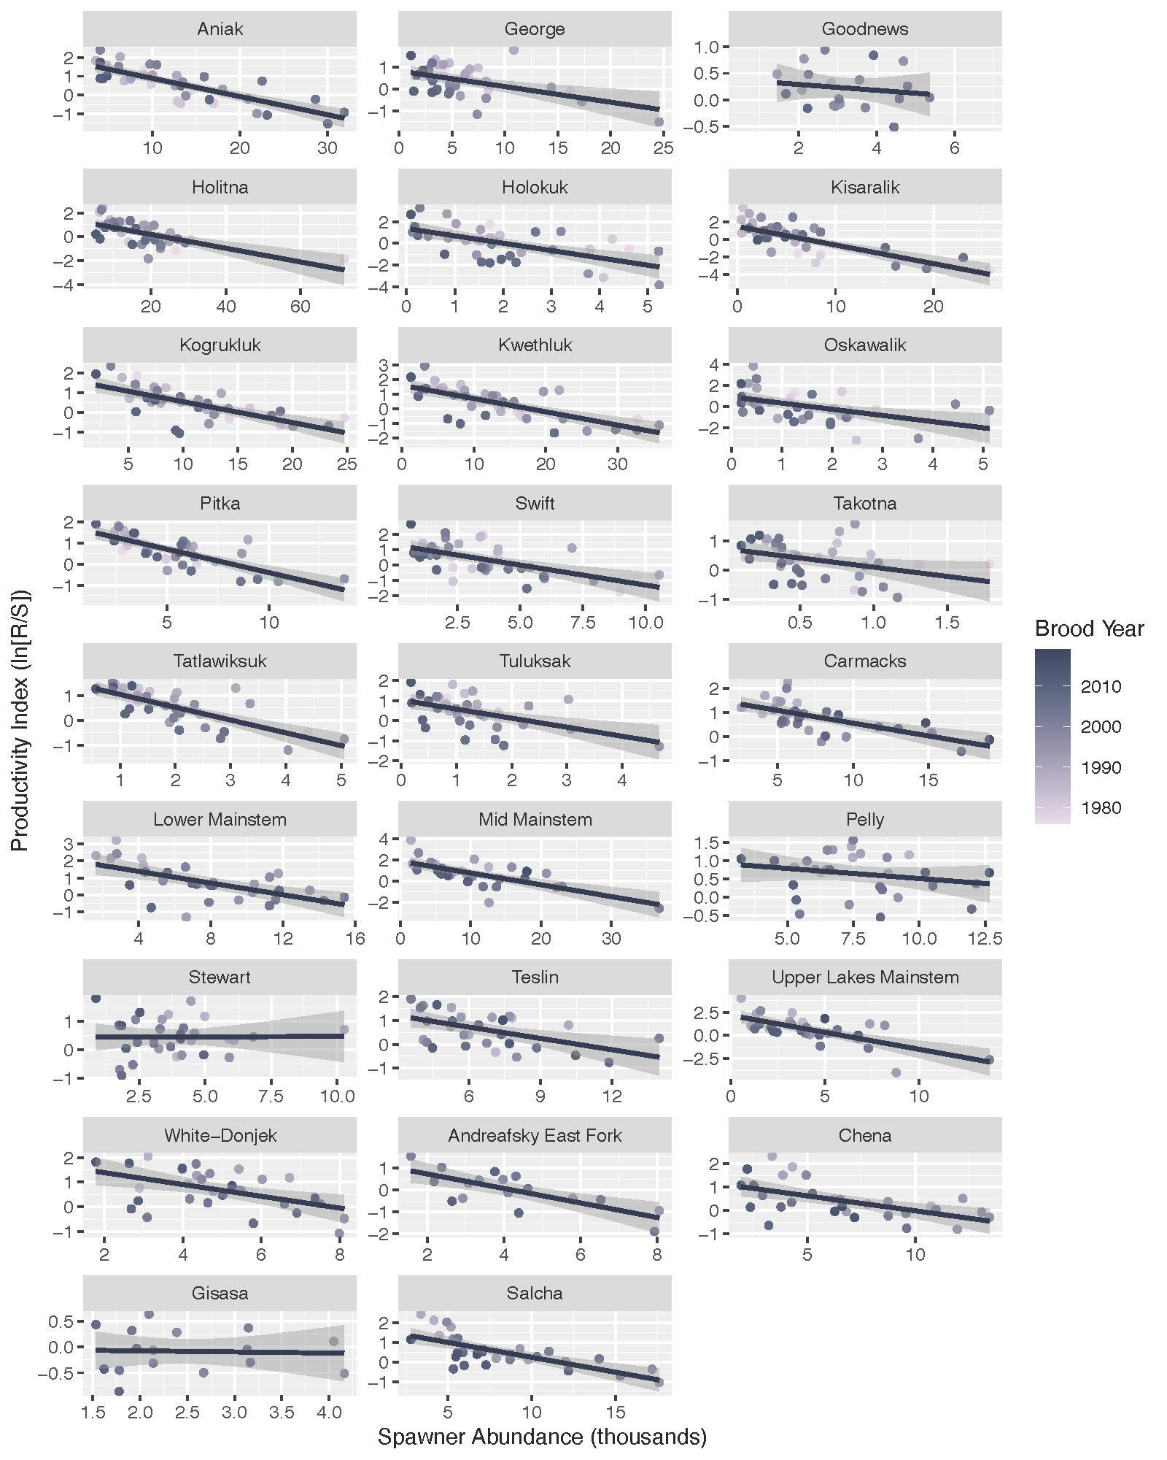

## Figure S3. Productivity versus Spawner Abundance

Natural log of recruits per spawner regressed against spawner abundance for all available years in which full returns have been observed. The time series of stock-recruitment data varied from 14 to 31 years across the populations. Line of best fit is a standard linear model (ggplot).

Beacham, T. D., J. R. Candy, K. L. Jonsen, J. Supernault, M. Wetklo, L. Deng, K. M. Miller, R. E. Withler, and N. Varnavskaya. 2006. Estimation of Stock Composition and Individual Identification of Chinook Salmon across the Pacific Rim by Use of Microsatellite Variation. Transactions of the American Fisheries Society 135: 861–88.

Beacham, T. D., C. Wallace, C. Macconnachie, K. Jonsen, B. McIntosh, J. R. Candy, and R. E. Withler. 2018. “Population and Individual Identification of Chinook Salmon in British Columbia through Parentage-Based Tagging and Genetic Stock Identification with Single Nucleotide Polymorphisms.” Canadian Journal of Fisheries and Aquatic Sciences 75: 1096–105.

Connors, B. M., Siegle, M. R., Harding, J., Rossi, S, Staton, B. A., Jones, M. L., Bradford, M. J., Brown, R., Bechtol, B., Doherty, B., Cox, S., & Sutherland, B. J. G. 2022. Chinook salmon diversity contributes to fishery stability and trade-offs with mixed-stock harvest. Ecological Applications, 32(8), e2709. <https://doi.org/https://doi.org/10.1002/eap.2709>

DFO (Department of Fisheries and Oceans Canada). 2018. Genetic Stock Identification of Canadian-Origin Yukon River Chinook and Fall Chum Salmon, 2017. Final Report CRE-79-17. Prepared for the Yukon River Panel.

Fleischman SJ, Evenson D. 2010. *Run reconstruction, spawner-recruit analysis, and escapement goal recommendation for summer Chum Salmon in the East Fork of the Andreafsky River*. Anchorage: Alaska Department of Fish and Game, Fishery Manuscript Series No. 10-04.

Froning, K. E., & Smith, N. J. 2020. Salmon age, sex, and length catalog for the Kuskokwim Area, 2018. Alaska Department of Fish and Game, Regional Information Report 3A20-06, Anchorage.

Joy, P.J., and, M. Tyers. In review. Run Reconstruction, Spawner-Recruit Analysis, and Escapement Goal Recommendation for Chinook Salmon in the Chena and Salcha Rivers. Alaska Department of Fish and Game, Fishery Manuscript Series, Anchorage.

Liller, Z.W., Hamazaki, H., Decossas, G., Bechtol, W., Catalano, M., and Smith, N. 2018. Kuskokwim River Chinook salmon run reconstruction model revision — executive summary. Regional Information Report 3A.18-04, Alaska Department of Fish and Game, Anchorage, Alaska.

Schaberg, K.L., Liller, Z.W., Molyneaux, D.B., Bue, B.G., and Stuby, L. 2012. Estimates of total annual return of Chinook salmon to the Kuskokwim River, 2002–2007. Fishery Data Series 12-36, Alaska Department of Fish and Game, Anchorage, Alaska.

Siegel JE. 2017. *Determinants of life history variability in the Chinook Salmon (Oncorhynchus tshawytscha) of western Alaska. Master's thesis*. Fairbanks: University of Alaska (see Supplemental Material, Reference S12).

Smith, N.J., and Liller, Z.W. 2017a. Inriver abundance and migration characteristics of Kuskokwim River Chinook salmon, 2015. Fishery Data Series 17-22, Alaska Department of Fish and Game, Anchorage, Alaska.

Staton, B. M., M. J. Catalano, B. M. Connors, L. G. Coggins, M. L. Jones, C. J. Walters, S. J. Fleichman, and D. C. Gwinn. 2020. Evaluation of methods for spawner-recruitment analysis in mixed-stock Pacific salmon fisheries. Can. J. Fish. Aquat. Sci. 77(7): 1149–1162.

Stuby, L. 2007. Inriver abundance of Chinook salmon in the Kuskokwim River, 2002–2006. Fishery Data Series 07-93, Alaska Department of Fish and Game, Anchorage, Alaska.

Taylor D. V. & Elison, T. B.. 2010. Kanektok River salmon monitoring and assessment, 2009. Alaska Department of Fish and Game, Fishery Data Series No. 10-57, Anchorage.

## 

# **Appendix S2:** Model estimates with simulated data

*Simulation Design*

Simulated data was used to test the model’s ability to estimate linear and nonlinear relationships and its sensitivity to type I and type II error with covariates. Spawner abundance for three Chinook salmon populations, *p*, were simulated from a lognormal distribution, each population had its own population mean ranging from 1,500 - 2,500 individuals, 80 - 100 years of data, and simulated observation error. Observation error for spawner abundance, $σ_{s,p,y}$, was simulated from a lognormal distribution with a mean of 0.5 and standard deviation of 0.1, and for recruits, $σ_{r,p,y}$, with a mean of 1 and standard deviation of 0.2. Observation error of both spawners and recruits varied by year of observation and population.

Three environmental covariates, $X_{p,t,c}$, representing standardized data were simulated from a normal distribution with a mean of 0 and standard deviation of 1. Number of recruits for each population, $R_{p,y}$, were calculated from simulated spawning data ($S_{p,y}$), known alpha ($α_{p}$) and beta ($β_{p}$) values, known covariate coefficients ($θ_{p,c}$), and the simulated environmental covariates as described in equation S1. Recruits were simulated from a lognormal distribution using the calculated recruit estimate and simulated observation error, $σ_{r,p,y}$. The model was fit to the data using equation S1.

$$S1. {\hat{R}}_{p,y}= {\hat{S}}_{p,y }exp(α_{p}- β_{p} {\hat{S}}_{p,y }+ \sum_{c}^{ }{(θ_{p,c}X_{p,t,c}))}$$

$$R_{p,y}∼normal({log(\hat{R}}_{p,y}) ,σ_{r,p,y})$$

Three types of covariate coefficients were included in the model to understand how well the model could estimate non-linear responses of Chinook salmon productivity to environmental drivers when the relationships were truly non-linear. The model was run three times: first, with only linear responses to covariates ($θ_{p,c}$, equation S1), second, with exponential response representing a threshold relationship to the covariates ($κ_{p,c}$, equation S2) and finally with both linear ($θ_{p,c}$, equation S2) and quadratic ($γ_{p,c}$, equation S3) responses to represent dome shaped relationships to covariates.

$$S2. {\hat{R}}_{p,y}= {\hat{S}}_{p,y }exp(α_{p}- β_{p} {\hat{S}}_{p,y }+ \sum_{c}^{ }{(κ_{p,c}exp⁡(X_{p,t,c})))}$$

$$R_{p,y}∼Lognormal({\hat{R}}_{p,y}, σ_{r,p,y})$$

$$S3. {\hat{R}}_{p,y}= {\hat{S}}_{p,y }exp(α_{p}- β_{p} {\hat{S}}_{p,y }+ \sum_{c}^{ }{(θ_{p,c}X_{p,t,c}+γ_{p,c}X_{p,t,c}^{2}))}$$

$$R_{p,y}∼Lognormal({\hat{R}}_{p,y}, σ_{r,p,y})$$

Posterior medians for the Ricker parameters, $β_{p}$ and $α_{p}$, and the covariate coefficients $θ_{p,c}$, $κ_{p,c}$, $γ_{p,c}$, were compared to their true, known (simulated) values to assess model performance and proclivity to type II error.

In addition to testing the model’s ability to identify non-linear relationships, we also tested how much error in spawner and recruit data would lead to inaccurate estimates of $θ_{p,c}$ in linear relationships. Three different error structures for spawner and recruit observation error were tested for linear relationships (Table S2; models 1, 4, 5). Model 1 represented error similar to the error expected in YK salmon data; models 4 and 5 represented error that exceeded the error expected in the salmon data. Finally, we fit six random (uncorrelated with salmon data) covariates to the observed salmon data. The goal of using randomly simulated covariate data was to determine whether the model would estimate spurious correlations (type I error) between salmon and covariates given the model and data structure.

*Simulation Results*

The model could estimate linear relationships between productivity and covariates when the underlying relationship was linear. The true coefficient value fell within the 95% credible interval of the posterior distribution for each of the three simulated populations and each of the three covariates (Figure S4A). The model was not able to accurately estimate the power term (threshold relationship), represented by $κ_{p,c}$ in model 2 – of the nine estimated coefficients, only three of the true values fell within the 95% credible interval (Figure S4B). For two coefficients, the model estimated a positive value when the underlying value was truly negative (Figure S4B; $κ_{1,2}$ and $κ_{3,1}$) and one estimated coefficient was a negative value when the underlying value was truly positive ($κ_{2,1}$). The model could estimate quadratic linear and nonlinear coefficients when the underlying relationships were nonlinear. The true coefficients for $θ_{p,c}$, the linear term, fell within the 95% credible interval of the posterior distribution for all covariates and all populations (Figure S4C). The true coefficient for $γ_{p,c}$, the quadratic term, fell within the 95% credible interval for all populations and all models (Figure S4D).

The model could estimate linear relationships with the parameter $θ_{p,c}$ for all error structures, even when the error in estimated spawner and recruit exceeded the error expected in YK Chinook salmon data (Figure S5). For all covariates, populations, and models, the true $θ_{p,c}$ fell within the 95% credible interval of the model estimated $θ_{p,c}$. Notably, for the error structure similar to Chinook salmon data (Figure S5A) the posterior distributions for $θ_{p,c}$ differed from 0 for all coefficients except $θ_{3,2}$ indicating limited evidence for type II error. For the other two error structures (Figure S5B & C) did not differ from 0 for most coefficients.

For the uncorrelated covariates, $θ_{c}$ the group level covariate effect (n = 6) did not differ from 0 for any of the randomly simulated covariates (Figure S6). Based on these results, we concluded posterior distributions for $θ_{p,c}$ and μθ,c that differ from 0 are most likely the result of correlations between Chinook salmon productivity and environmental conditions and not the result of spurious relationships caused by uncertainty in the data (type 1 error).

## Table S3. Simulated Models

Models fit to simulated data including the simulated relationship between covariates and productivity, the modeled response, covariates, and spawner ($σ_{s,p,y}$) and recruit ($σ_{r,p,y}$) observation error structure.

|  |  |  |  |
| --- | --- | --- | --- |
| Simulated Relationship | Modeled Response | Covariates | Error |
| 1. Linear coefficient | Linear  Equation 1 |  | 1. |
| 1. Power coefficient   (threshold response) | Power  Equation 2 |  | 1. |
| 1. Quadratic coefficient   (dome shaped response) | Quadratic, Linear  Equation 3 | , | 1. |
| 1. Linear Error 2 | Linear  Equation 1 |  | 2.  2. |
| 1. Linear Error 3 | Linear  Equation 1 | $$θ_{p,c}$$ | 3. 3. |

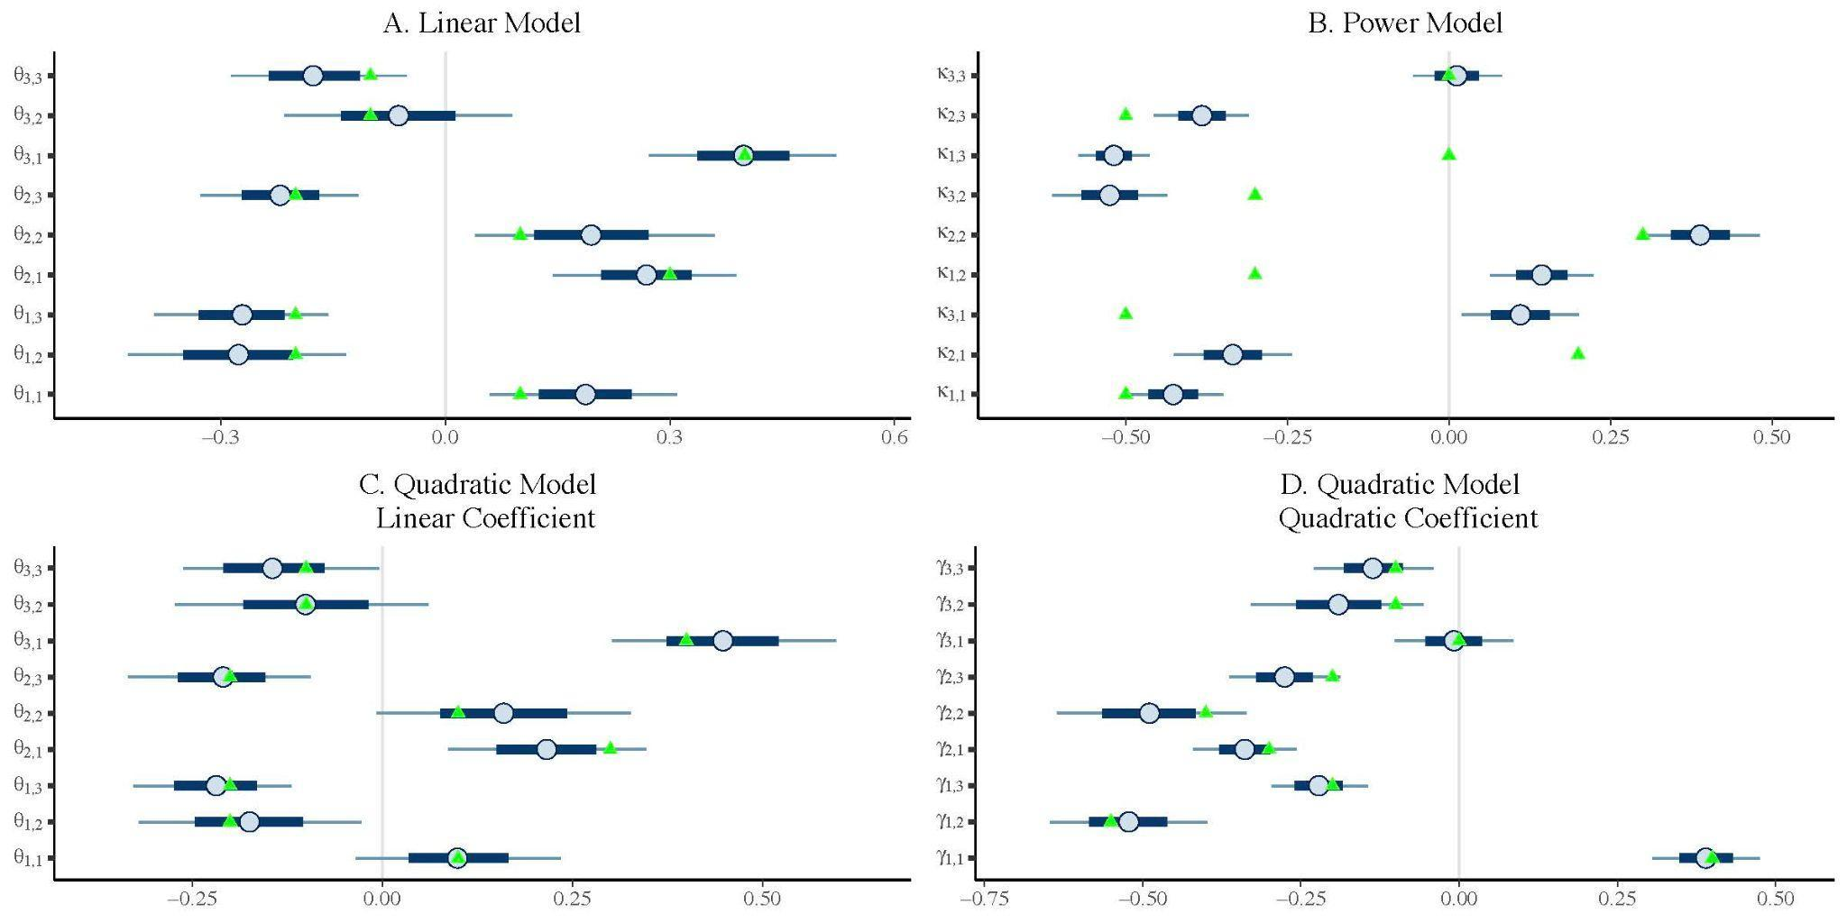

## Figure S4. Simulated Non-linear Relationships

Models 1-3 estimating linear (A. model 1, C. model 3), and nonlinear (B. model 2, power) and (D. model 3, quadratic) relationships. Green triangles are the true values for each coefficient ($θ_{p,c}$, $γ_{p,c}$, $κ_{p,c}$) and blue points are the model estimated median of the posterior distribution for a given covariate. The inner tail represents the 80% credible interval, and the outer tail represents the 95% credible interval of the model posterior.

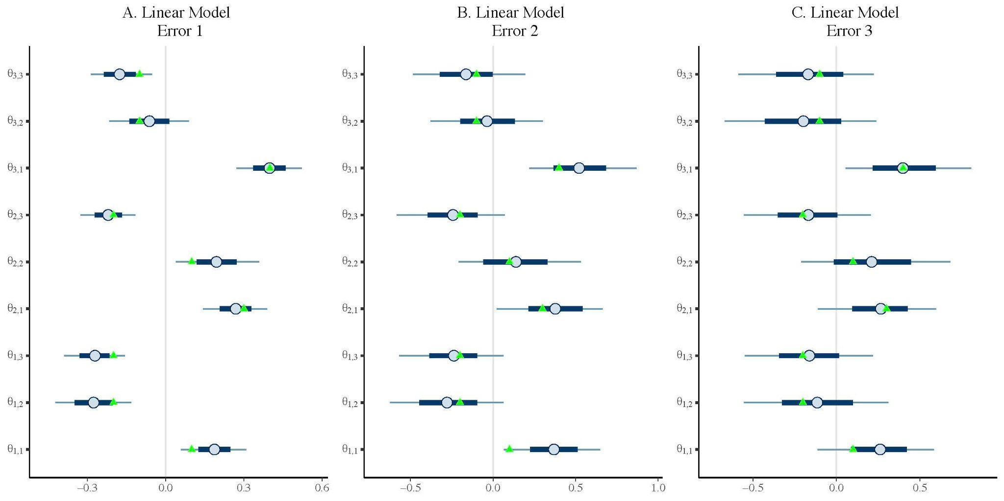

## Figure S5. Simulated Error Results

Models 1, 4, and 5 estimating linear relationships to three covariates using three different error distributions. Green triangles are the true values for each coefficient ($θ_{p,c}$) and blue points are the model estimated median of the posterior distribution for a given covariate. The inner tail represents the 80% credible interval, and the outer tail represents the 95% credible interval of the model posterior. Distributions that do not differ from 0 indicate type II error.

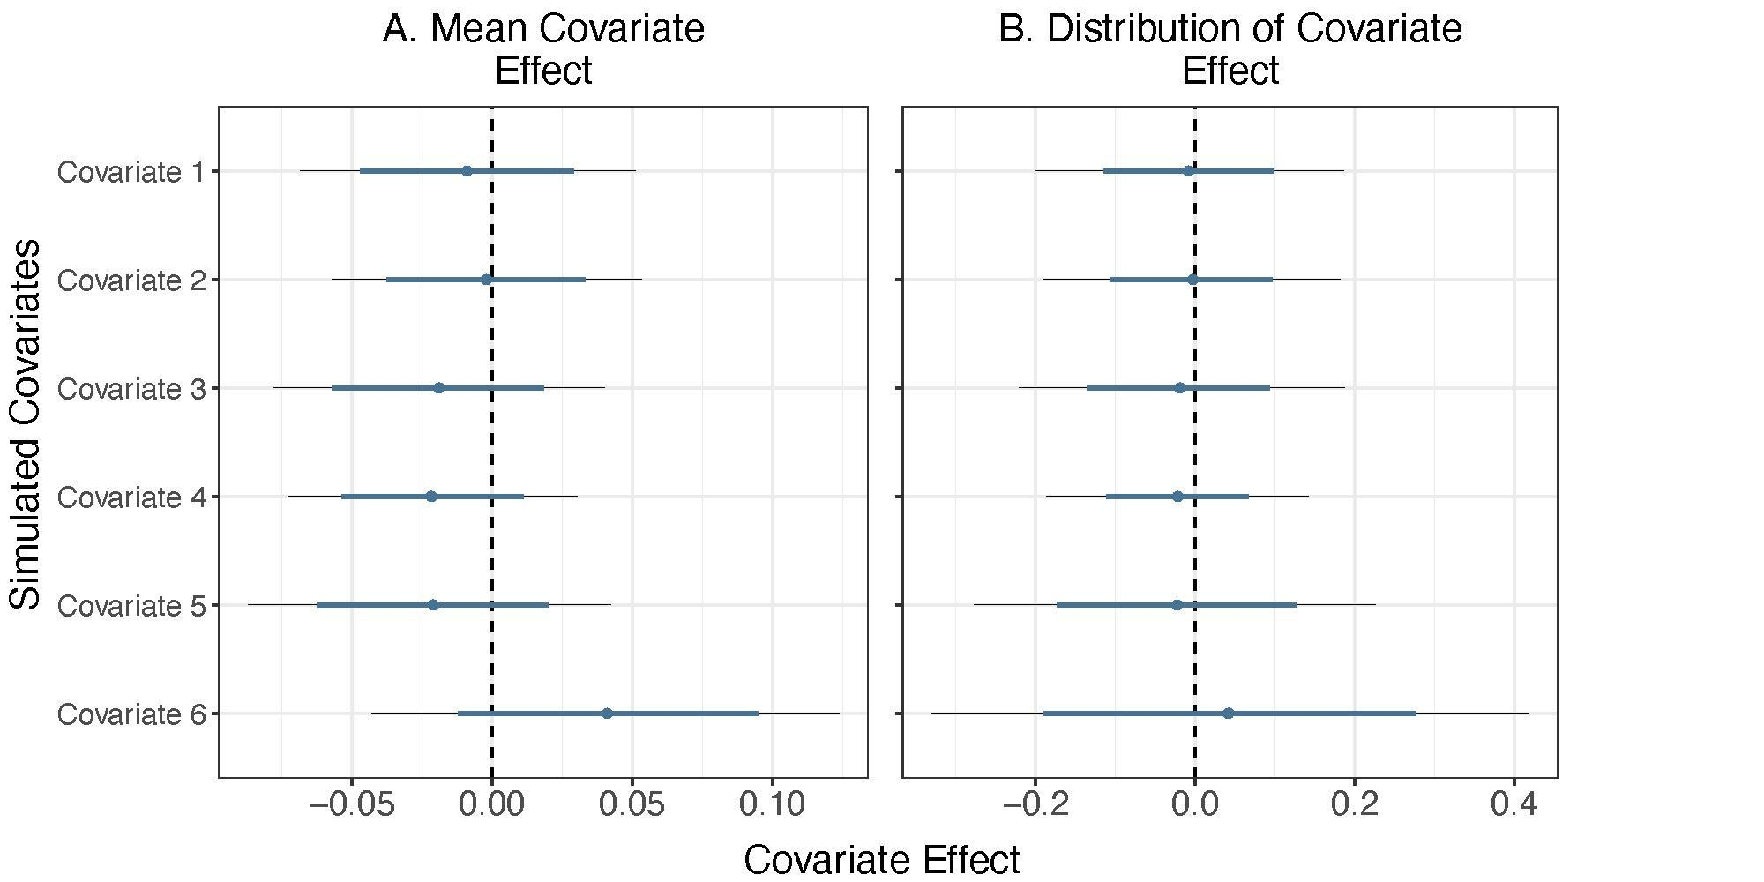

## Figure S6. Simulated Null Covariate Results

Regional mean effects of simulated null covariates on a single simulated Chinook salmon population productivity (log recruits per spawner). Points describe the median estimated effect of each null covariate on productivity (μθ,c) , while the thick colored and thin black lines describe the uncertainty (50% and 95% credible intervals, respectively). The black line centered at zero represents the true simulated effect on productivity. Distributions that differ from 0 indicate spurious correlations with null covariates indicative of type I error.

# **Appendix S3:** Dynamic factor analysis to combine covariate data

Dynamic factor analyses (DFA) were fit to two covariate datasets to generate indices of overall regional temporal trends in marine interactions/competitors and Chinook salmon body size. DFA is commonly applied in ecology and has been used to identify patterns of oceanographic variability that drive Pacific salmon stocks (Stachura et al. 2014) and environmental drivers and stock structure of Chinook salmon (Jorgenson et al. 2016, Ohlbereger et al. 2016). This approach is a dimension reduction technique that identifies common processes underlying a set of time series and estimates loadings (coefficients) for the strength of the relationship of each time series on the trend. The underlying model in DFA treats observed data as linear combinations of latent unobservable "trends" which are modeled as a random walk (Zuur et al. 2003). Latent variables are weighted based on the portion of temporal variation they explain where time series for female body size and marine competitor abundance, **y*,*** were modeled as linear combinations of latent trends (**x**) with observation errors ($v$):

S4. $y_{t}= {Zx}_{t }+ v_{t }$, where

$$v_{t }\sim MVN(0,R)$$

**Z** is a matrix of factor loadings on the latent trends. The observation equation assumes the time series have a mean of 0 and that the errors are normally distributed (MVN: multivariate normal) with mean zero and variance-covariance matrix **R**. The latent trends (**x**) are modeled as a random walk with process error (**w**):

S5. $x_{t }= x_{t-1 }+ w_{t },$ where

$$w_{t }\sim MVN(0,Q)$$

Process error is assumed to be normally distributed with mean zero and variance-covariance matrix **Q**. Model parameters and states were estimated using the MARSS package (Holmes et al. 2012).

Data of Chinook salmon body size were collated and archived in by Clark et al. (2018) and Oke et al. (2022) from age, sex, and length projects across Alaska and were updated from 2018 - 2022 using the Alaska Department of Fish and Game Arctic-Yukon-Kuskokwim Database Management System. Observations for escapement only were included in this analysis, as they were deemed to be less impacted by gillnet size-selectivity (e.g., Bromaghin 2005) than observations from commercial, subsistence, and test fisheries. Time series that contained at least five years of data between 1980 and 2017 were identified for both the Yukon watershed and the Kuskokwim watershed and were updated with additional years of data 2018 - 2022 from the ADF&G AYK Public Database Management System (note: these updated years were only used to plot trends in Figure 6). For the Kuskokwim and Yukon subregions, nine and 12 time series, respectively, were identified representing population-specific length measurements. Two separate dynamic factor analyses were performed, one for each the Yukon and Kuskokwim subregions. The response variable **y** was mean length of escaped Chinook salmon and these time series were standardized about a mean of 0 and a standard deviation of 1. This means 0 represents the long-term average Chinook salmon size across tributaries. Both analyses assumed that process error (**Q**) had equal variance and unequal covariance across tributaries and that observation error (**R**) had equal variance and covariance across tributaries.

Annual abundance estimates of natural and hatchery produced pink salmon (*O. gorbuscha*) and chum salmon (*O. keta*) in the Bering Sea and North Pacific Ocean were compiled from the North Pacific Anadromous Fish Commission database and North Pacific Fisheries Commission documents by Ruggerone and Irvine (2018). Time series of annual biomass of adult walleye pollock (*Gadus chalcogrammus*) and annual recruits of juvenile pollock were compiled from stock assessment reports (Ianelli et al. 2020). These datasets were identified to be highly correlated (Appendix S5) with other covariates of interest and a dynamic factor analysis was performed to reduce overfitting by identifying an overall trend in marine predators and competitors. The response variable **y** was annual abundance of North Pacific chum salmon, North Pacific pink salmon, age 3+ walleye pollock in the eastern Bering Sea and walleye pollock annual recruits in the eastern Bering Sea. These time series were standardized and assumed process error (**Q**) was unconstrained and observation error (**R**) was unconstrained across species and age class. We considered both a 3 year and a 4 year temporal lag for each time series to align with the marine residence of the Chinook salmon brood year.

The latent trend for Chinook salmon body size in the Kuskokwim watershed declined substantially from 1980 - 2022 (Figure S8). 7 of the 9 rivers had strong, positive factor loadings on the latent trend. The Kwethluk River has a weak, positive factor loading on the latent trend and the Tuluksak River had a weak, negative factor loading on the latent trend. Both rivers with weak factor loadings on the latent trend only had 2-4 years of size data prior to 2000 (Figure S9). For all rivers in the Kuskokwim watershed, the observed data fell within a 95% confidence interval of the DFA model predictions (Figure S9).

The latent trend for Chinook salmon body size in the Yukon watershed increased from 1980 - 1986 and then declined from 1986 - 2022 (Figure S10). 10 of the 12 rivers had positive factor loadings on the latent trend with the strongest loadings for the Chena, Salcha, and Gisasa rivers. The Tatchun Creek and the Tozitna River had negative, weak, loadings, and both rivers only had 10 years of data (Figure S11). For all rivers in the Yukon watershed, the observed data fell within a 95% confidence interval of the DFA model predictions (Figure S11).

The latent trend for walleye pollock and pink and chum salmon showed a drastic increase from 1981 to 2000 before remaining relatively stable (Figure S12). Pink and chum salmon, and age 3+ walleye pollock had strong positive loadings on the trend but walleye pollock recruits had a weak, negative loadings. For each species and age class the observed data fell within a 95% confidence interval of the DFA model prediction, but the model prediction better characterized the oscillations in abundance for pink and chum salmon than adult or juvenile walleye pollock.

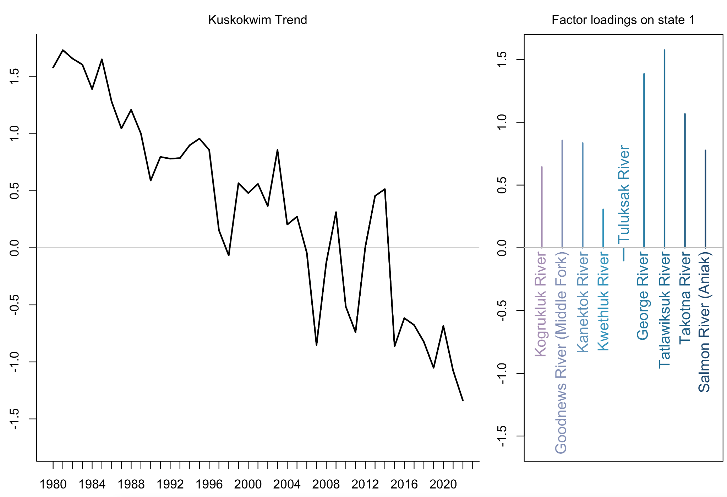

## Figure S7. DFA Size Latent Trend and Loadings (Kuskokwim)

Latent trend (left) and factor loadings (right) for the size of Kuskokwim Chinook salmon from nine rivers that had at least five years of observations.

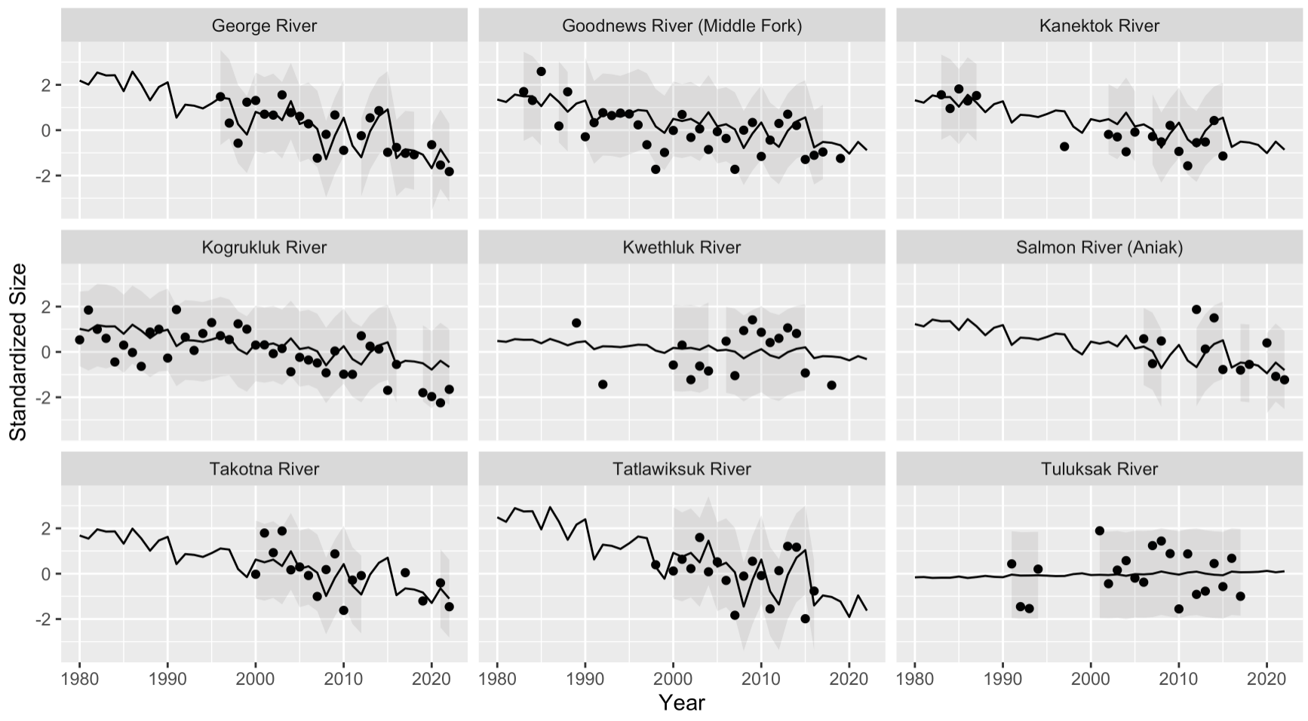

## Figure S8. DFA Size Model Fits (Kuskokwim)

Fits of DFA model (line, shaded area) to data (points)

# 

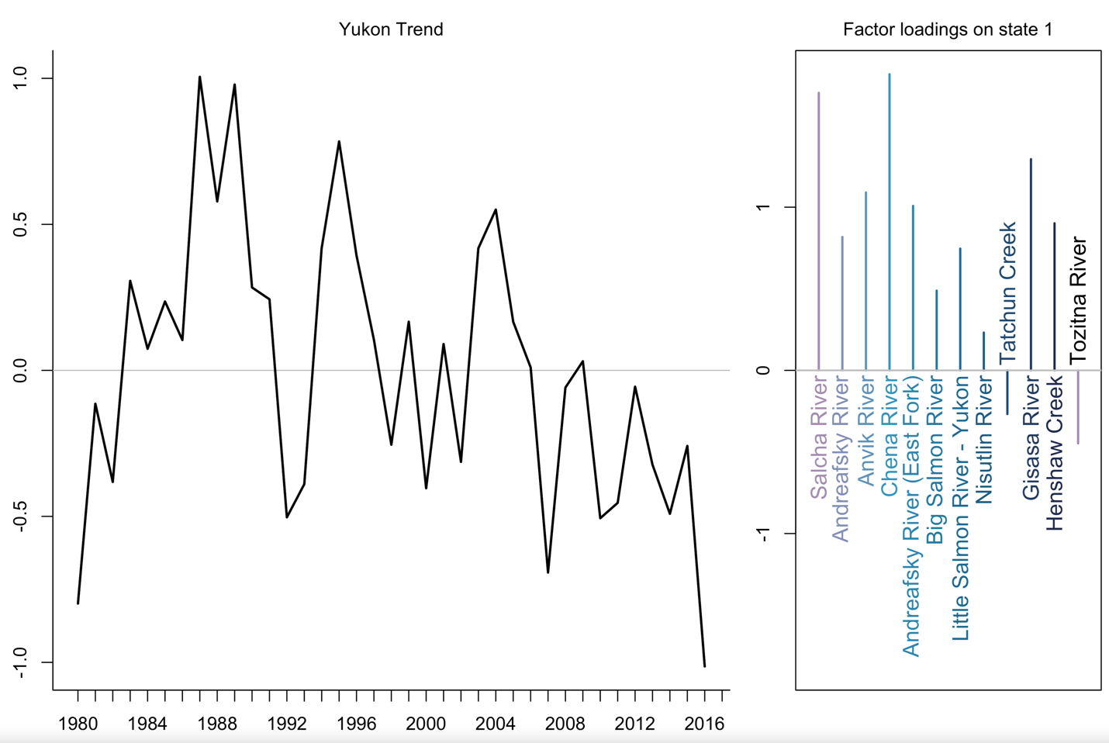

## Figure S9. DFA Size Latent Trend and Loadings (Yukon)

Latent trend (left) and factor loadings (right) for the size of Yukon watershed Chinook salmon from 12 rivers that had at least five years of observations and multiple fish for each year.

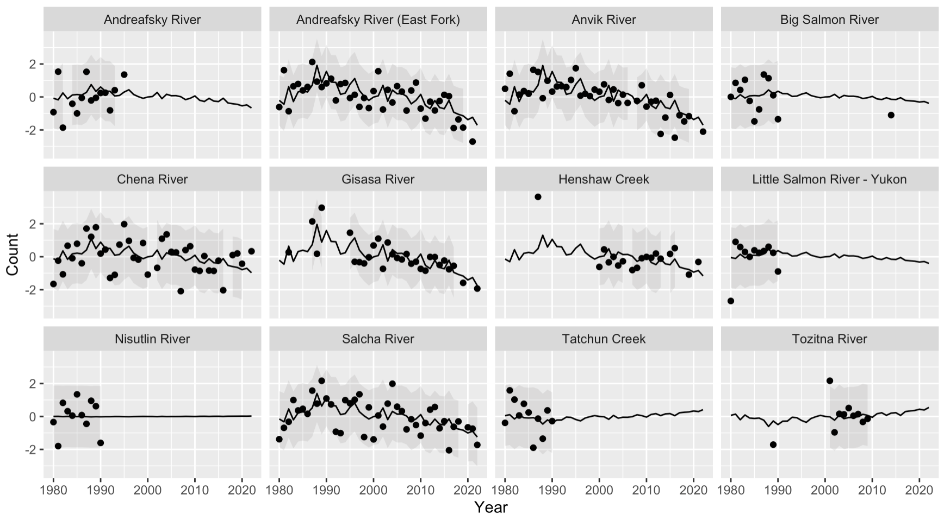

## Figure S10. DFA Size Model Fits (Yukon)

Fits of DFA model (line, shaded area) to data (points)

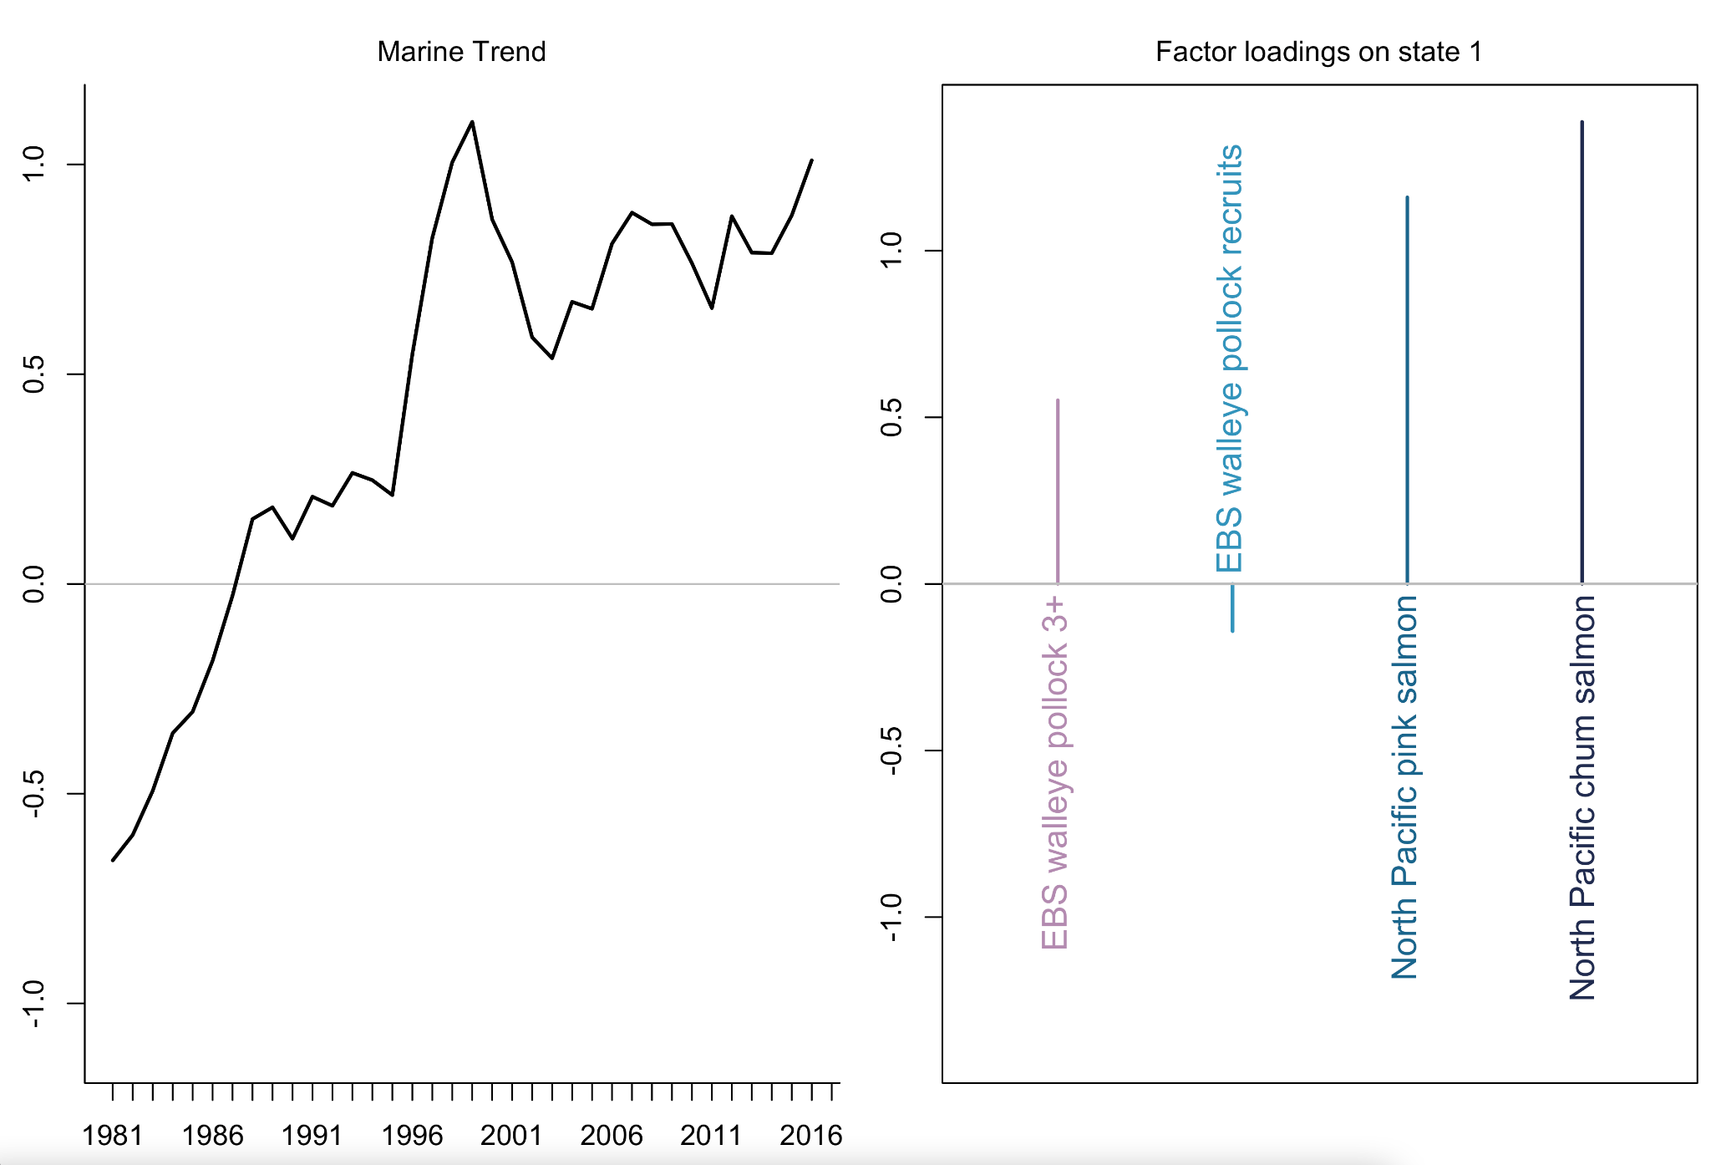

## Figure S11. DFA Marine Competitor Latent Trend and Loadings

Latent trend (left) and factor loadings (right) for the abundance of North Pacific chum salmon, North Pacific pink salmon, age 3+ walleye pollock in the eastern Bering Sea, and walleye pollock recruits in the eastern Bering Sea from 1981 - 2016.

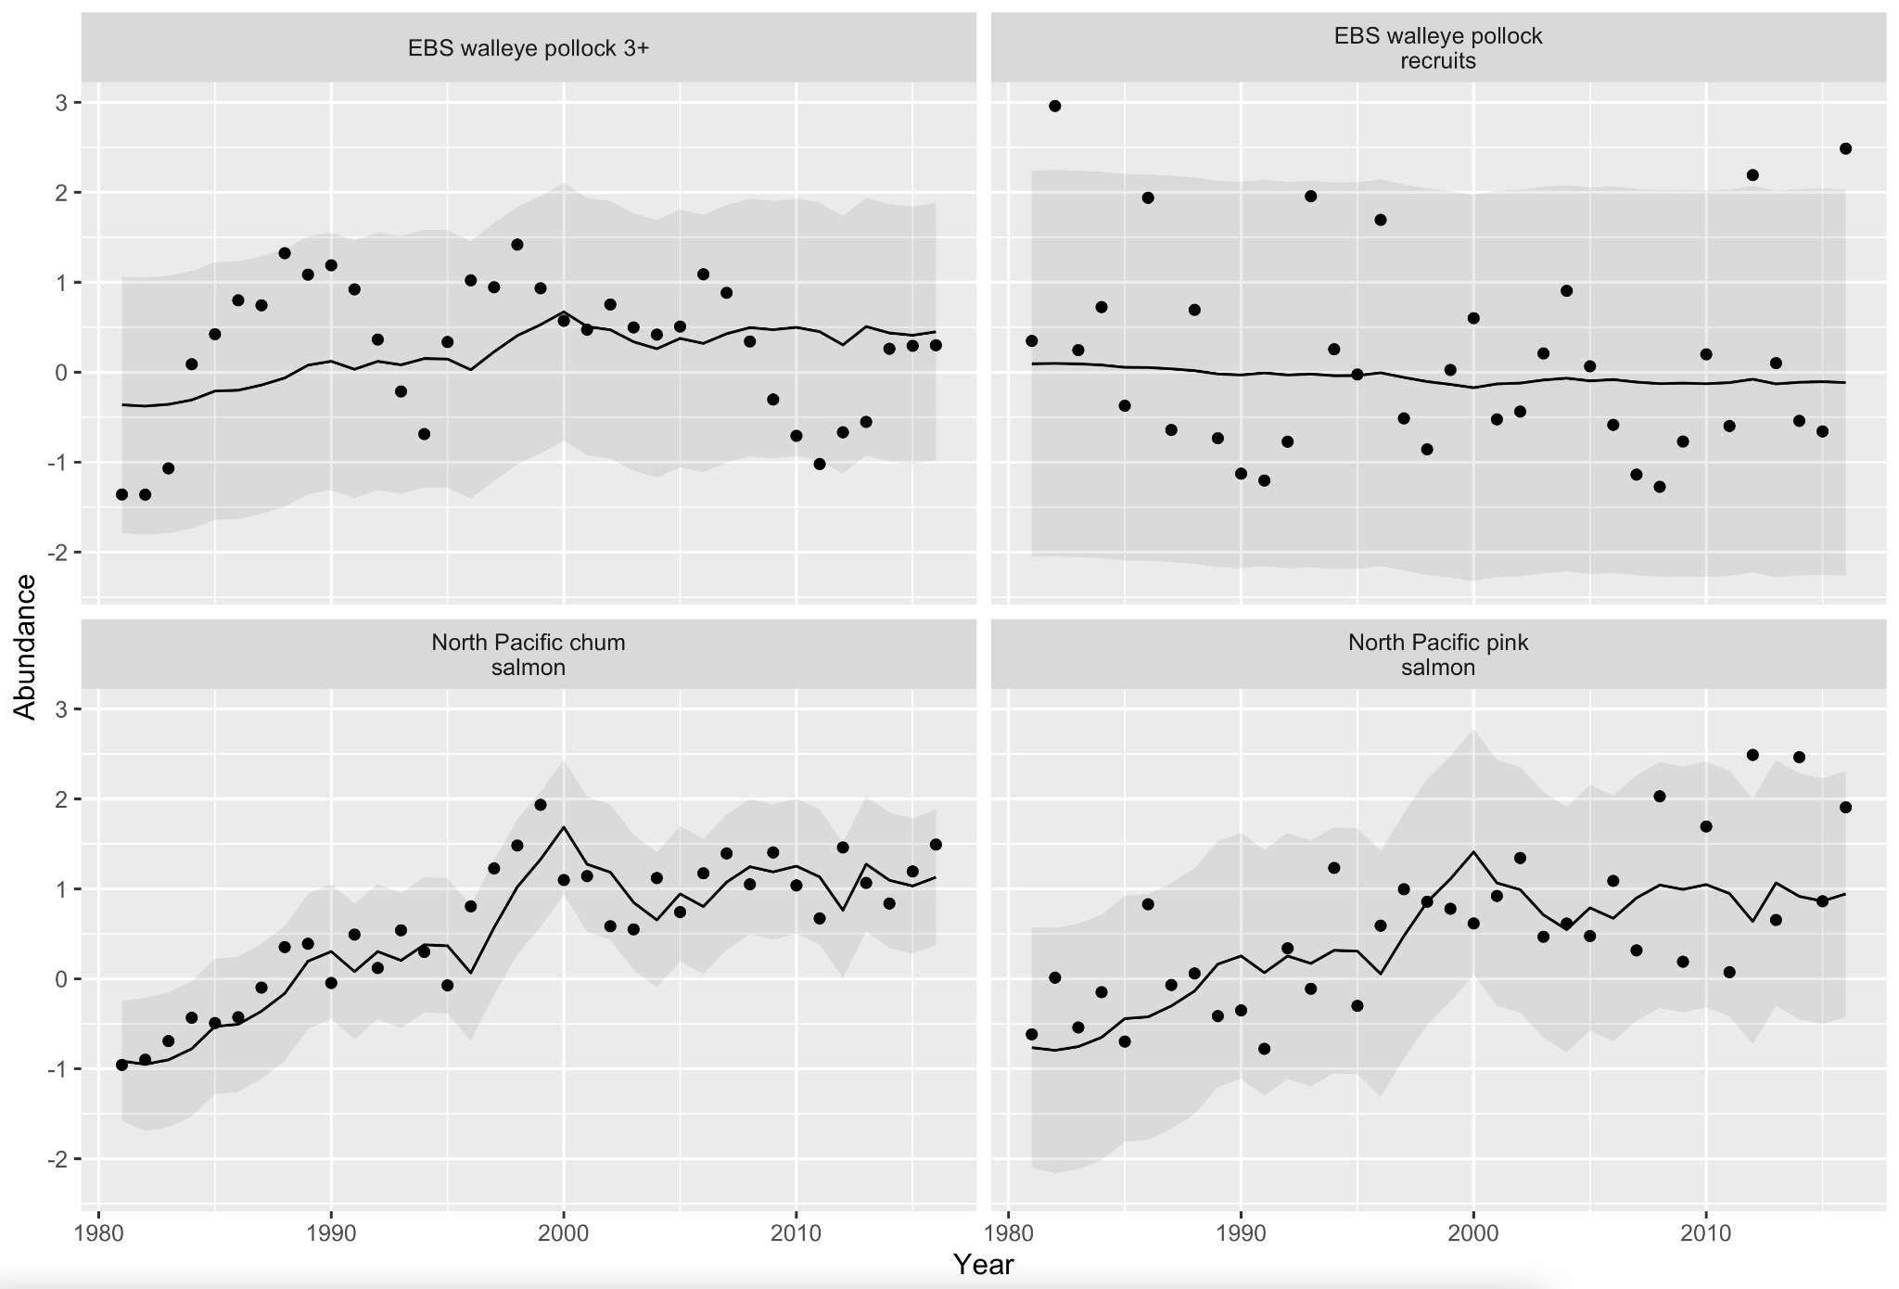

## Figure S12. DFA Marine Competitor Model Fits

Fits of DFA model (line, shaded area) to data (points)

Bromaghin, J.F. 2005. A versatile net selectivity model, with application to Pacific salmon and freshwater species of the Yukon River, Alaska. Fisheries Research **74**(1): 157–168. doi:[10.1016/j.fishres.2005.03.004](https://doi.org/10.1016/j.fishres.2005.03.004).

Clark, J., Brenner, R., & Lewis, B. 2018. Compiled age, sex, and length data for Alaskan salmon, 1922 - 2017. Knowledge for Network Biocomplexity. doi:10.5063/F1707ZTM

Ianelli, J., Fissel, B., Holsman, K., De Robertis, A., Honkalehto, T., Kotwicki S., Monnahan, C., Siddon, E., & Thorson, J. 2020. Chapter 1: Assessment of the Walleye Pollock Stock in the Eastern Bering Sea. In: Stock Assessment and Fishery Evaluation Report for the Groundfish Resources of the Bering Sea/Aleutian Islands Regions, Alaska Fisheries Science Center, National Marine Fisheries Service, Seattle, WA.

Holmes, E. E., Ward, E. J., & Kellie, W. 2012. MARSS: multivariate autoregressive state-space models for analyzing time-series data. R J., 4(1), 11.

Jorgensen, J. C., Ward, E. J., Scheuerell, M. D., & Zabel, R. W. 2016. Assessing spatial covariance among time series of abundance. Ecology and Evolution, 6(8), 2472-2485.

Ohlberger, J., Scheuerell, M. D., & Schindler, D. E. 2016. Population coherence and environmental impacts across spatial scales: A case study of Chinook salmon. *Ecosphere,* 7(4), e01333. <https://doi.org/10.1002/ecs2.1333>

Ruggerone, G. T., & Irvine, J. R. 2018. Numbers and biomass of natural‐and hatchery‐origin pink salmon, chum salmon, and sockeye salmon in the north Pacific Ocean, 1925–2015. Marine and Coastal Fisheries, 10(2), 152-168. https://doi.org/10.1002/mcf2.10023

Stachura, M. M., Mantua, N. J., & Scheuerell, M. D. 2014. Oceanographic influences on patterns in North Pacific salmon abundance. Canadian Journal of Fisheries and Aquatic Sciences, 71(2), 226-235. <https://doi.org/10.1111/fog.12458>

Zuur, A. F., Fryer, R. J., Jolliffe, I. T., Dekker, R., & Beukema, J. J. 2003. Estimating common trends in multivariate time series using dynamic factor analysis. Environmetrics: The Official Journal of the International Environmetrics Society, 14(7), 665-685.

Zuur, A. F., Tuck, I. D., & Bailey, N. 2003. Dynamic factor analysis to estimate common trends in fisheries time series. Canadian Journal of Fisheries and Aquatic Sciences, 60(5), 542-552

# **Appendix S4:** Freshwater covariate processing

Freshwater covariates were developed to represent hydrologic and thermal conditions specific to habitats used by different life stages and populations in the YK study region and identified during workshop discussion (Feddern 2023). This section includes methods for filling data gaps in streamflow and stream temperature time series required to test hypotheses related to (a) streamflow effects on egg survival and juvenile growth and (b) stream temperature effects on adult reproductive success and juvenile growth. The methods presented here are a summary of a concurrent research effort to compare and select optimal gridded climate products for estimating freshwater habitat conditions in the Yukon and Kuskokwim basins (Shaftel et al. In Prep.).

To develop time series of hydrologic conditions, we used modeled discharge from the Global Flood Awareness System [(GloFAS, Harrigan et al. 2020)](https://www.zotero.org/google-docs/?9jW52I) and selected a single habitat representing hydrologic conditions for each population and life stage. For the Kuskokwim (n = 14) and U.S. Yukon (n = 4) populations, we extracted data from the watershed outlet for each tributary for our two hypotheses related to spawning and rearing. For the Canadian Yukon genetic population units (n = 8), we extracted data from the major spawning areas mapped to tributaries and, where there was more than one major spawning area within a genetic population units, selected the major spawning area that likely supported the largest Chinook Salmon spawning population [(Brown et al. 2017)](https://www.zotero.org/google-docs/?pNFcCK). For each year and population, we calculated the maximum daily streamflow in the fall months when peak streamflows overlap the incubation window (August through November, Curran et al. 2021) and the median daily streamflow in the summer (May through September) as our annual covariates of hydrologic conditions hypothesized to affect egg survival and juvenile growth, respectively.

To develop indices of thermal conditions for each life stage and population, we modeled daily mean stream temperatures using a combination of climatic and hydrologic predictor variables. Empirical stream temperature data for four mainstem and 27 tributary sites were received from the Alaska Department of Fish and Game, the U.S. Fish and Wildlife Service, and Al Von Finster (retired biologist with the Department of Fisheries and Oceans Canada) and combined with U.S. Geological Survey data that were directly downloaded using the ‘DataRetrieval’ R package [(De Cicco et al. 2022, R Core Team 2022)](https://www.zotero.org/google-docs/?7yfGcT). Stream temperature data were not available for five Kuskokwim River tributaries so information was borrowed from nearby sites (George River data were used to fill data gaps for the Holitna, Holokuk, and Oskawalik Rivers; Kwethluk River data were used for the Kisaralik River; and Tatlawiksuk data were used to inform conditions in the Swift River). Predictor variables in our model included Julian day, lagged daily mean air temperatures, mean watershed April 1st snow-water-equivalent (SWE), and daily streamflow. Air temperatures and SWE were from DAYMET, a gridded daily weather data product [(Thornton et al. 2021)](https://www.zotero.org/google-docs/?tUmMY1) and streamflow was from GloFAS.

Models were developed separately for two seasons within a year based on the average timing of maximum stream temperatures (before or after July 23). Developing models for rising and falling stream temperatures over each season improves model accuracy by allowing for variable parameter coefficients and using Julian day to explain a significant portion of the warming and cooling trends [(McNyset et al. 2015)](https://www.zotero.org/google-docs/?3AVX0D). We tested for significant lags between air temperatures and stream temperatures for each monitoring site using a cross-correlation function after prewhitening. Prewhitening is a useful technique for finding optimal lags between a predictor and response when there is a time series structure to the predictor variable and common trends between the predictor and response variables. The steps include fitting an autoregressive time series model to the predictor variable, filtering both time series using the AR model, and then fitting the cross-correlation function to the filtered data [(Shumway and Stoffer 2011)](https://www.zotero.org/google-docs/?IX2GYN). Prewhitening was performed using the Time Series Analysis ‘TSA’ R package [(Chan and Ripley 2022)](https://www.zotero.org/google-docs/?2SbGkQ).

For each monitoring site, we fit two seasonal boosted regression tree models using a tree complexity of three to allow for variable interactions, a learning rate of 0.1 to stabilize the prediction variance, and a bag fraction of 0.5 (only half of the observations are used in each new tree) to reduce overfitting and improve prediction accuracy [(Elith et al. 2008)](https://www.zotero.org/google-docs/?hrLu7B). We used 10-fold cross validation and calculated the root-mean-squared-prediction-error (RMSPE) from the cross-validated stream temperature predictions to summarize model performance. Spring mean RMSPE across all sites was 0.74°C and fall mean RMSPE was 1.0°C. Boosted regression trees were fit using the ‘gbm’ R package [(Greenwell et al. 2022)](https://www.zotero.org/google-docs/?BmIV3j). We used the models to predict mean daily stream temperatures for May through September from 1980 to 2018 and subsequently calculated annual stream temperature covariates for each site.

For each population in the productivity model, we used modeled stream temperatures from 31 mainstem or tributary monitoring sites to estimate thermal conditions experienced by different life stages. Because adults migrate through both the mainstem and tributaries prior to spawning and thermal stress could occur anywhere along the migration route, we used migration timing information to filter modeled stream temperatures from mainstem and tributary habitats prior to calculating annual covariates.

Migration temperatures in the mainstem corridors were selected from a single monitoring site for each population. For populations in the Kuskokwim watershed, we used data collected at the Kalskag fish wheel for estimating thermal conditions during migration because it had the most years of continuous stream temperature data. For U.S. Yukon populations, we used stream temperature data from Pilot Station because all four populations pass through this site en route to spawning habitats. For the Canadian Yukon genetic substocks, we used data from the Rapids fish wheel at Rampart, Alaska because this site generally had the warmest stream temperatures of any mainstem Yukon temperature site (Figure S14). Timing windows were used to filter the modeled stream temperatures from each habitat and calculate a metric of adult heat stress: the annual maximum of mean daily stream temperatures (maxMnT. For juvenile growth, we calculated the cumulative degree days during the summer growing season (May through September) from the tributary habitats used by each population. For six populations (n = 5 in the Kuskokwim and one in the Canadian Yukon) that lacked stream temperature data in their watershed, we used temperature covariates from the closest similarly sized tributary.

## Figure S13. A graph showing the temperature of a stream Description automatically generatedMainstem Maximum Daily Stream Temperatures

Predicted annual maximum daily stream temperatures at four monitoring sites on the Yukon River and one site on the Kuskokwim River (Kalskag). From downstream to upstream, the sites are Pilot Station, Rampart (also known as Rapids Fish Camp), Eagle, and Yukon at Carmacks.

[Brown, R. J., von Finster, A, Henszey, R. J., & Eiler, J. H. 2017. Catalog of Chinook Salmon Spawning Areas in Yukon River Basin in Canada and United States. Journal of Fish and Wildlife Management, 8, 558–586.](https://www.zotero.org/google-docs/?OhFQSf)

[Chan, K., & Ripley B. 2022. TSA: Time Series Analysis.](https://www.zotero.org/google-docs/?OhFQSf)

[Clark, J. N., & Smith, N. J. 2019. Inriver abundance and run timing of Kuskokwim River Chinook salmon, 2017. Fishery Data Series, Alaska Department of Fish and Game, Division of Commercial Fisheries, Anchorage, AK.](https://www.zotero.org/google-docs/?OhFQSf)

[Cline, T. J., Schindler, D. E., Walsworth, T. E., French, D. W., & Lisi, P. J. 2020. Low snowpack reduces thermal response diversity among streams across a landscape. Limnology and Oceanography Letters, 5, 254–263.](https://www.zotero.org/google-docs/?OhFQSf)

Curran, J. H., & F. E. Biles. 2021. Identification of seasonal streamflow regimes and streamflow drivers for daily and peak flows in Alaska. Water Resources Research, 57, 57:e2020WR028425.

[De Cicco, L. A., Hirsch, R. M., Lorenz, D., & Watkins, W. D. 2022. dataRetrieval: R packages for discovering and retrieving water data available from Federal hydrologic web services.](https://www.zotero.org/google-docs/?OhFQSf)

[Eiler, J. H., Evans, A. N., & Schreck, C. B. 2015. Migratory patterns of wild Chinook Salmon (Oncorhynchus tshawytscha) returning to a large, free-flowing river basin. PLOS ONE, 10, e0123127.](https://www.zotero.org/google-docs/?OhFQSf)

[Elith, J., Leathwick, J. R., & Hastie, T. 2008. A working guide to boosted regression trees. Journal of Animal Ecology, 77, 802–813.](https://www.zotero.org/google-docs/?OhFQSf)

Falke, J. A., Huntsman, B. M., & Schoen, E. R. 2019. Climatic variation drives growth potential of juvenile Chinook Salmon along a subarctic boreal riverscape. In American Fisheries Society Symposium (Vol. 90, pp. 57-82).

[Greenwell, B., Boehmke, B., Cunningham, J., & Developers, G.. 2022. gbm: Generalized Boosted Regression Models.](https://www.zotero.org/google-docs/?OhFQSf)

[Harrigan, S., Zsoter, E., Alfieri, L., Prudhomme, C., Salamon, P., Wetterhall, F., Barnard, C., Cloke, H., & Pappenberger, F. 2020. GloFAS-ERA5 operational global river discharge reanalysis 1979–present. Earth System Science Data, 12, 2043–2060.](https://www.zotero.org/google-docs/?OhFQSf)

Jones, L. A., Schoen, E. R., Shaftel, R., Cunningham, C. J., Mauger S., Rinella D. J., & St. Saviour A.. 2020. Watershed-scale climate influences productivity of Chinook salmon populations across southcentral Alaska. Global Change Biology, 26(9), 4919–4936. https://doi.org/10.1111/gcb.15155

[McNyset, K., Volk, C., & Jordan, C. 2015. Developing an Effective Model for Predicting Spatially and Temporally Continuous Stream Temperatures from Remotely Sensed Land Surface Temperatures. Water, 7, 6827–6846.](https://www.zotero.org/google-docs/?OhFQSf)

[Neuswanger, J. R., Wipfli, M. S., Evenson, M. J., Hughes, N. F., & Rosenberger, A. E. 2015. Low productivity of Chinook salmon strongly correlates with high summer stream discharge in two Alaskan rivers in the Yukon drainage. Canadian Journal of Fisheries and Aquatic Sciences, 72, 1125–1137.](https://www.zotero.org/google-docs/?OhFQSf)

[R Core Team. 2022. R: A language and environment for statistical computing. R Foundation for Statistical Computing. Vienna, Austria.](https://www.zotero.org/google-docs/?OhFQSf)

[Shumway, R. H., & Stoffer, D. S. 2011. Time Series Analysis and Its Applications. Third. Springer, New York.](https://www.zotero.org/google-docs/?OhFQSf)

[Thornton, P. E., Shrestha, R., Thornton, M., Kao, S. C., Wei, Y., &. Wilson, B. E. 2021. Gridded daily weather data for North America with comprehensive uncertainty quantification. Scientific Data, 8, 190.](https://www.zotero.org/google-docs/?OhFQSf)

von Biela, V. R., Bowen, L., McCormick, S. D., Carey, M. P., Donnelly, D. S., Waters, S., Regish, A. M., Laske, S. M., Brown, R. J., & Larson, S. 2020. Evidence of prevalent heat stress in Yukon River Chinook salmon. Canadian Journal of Fisheries and Aquatic Sciences, 77(12), 1878–1892. https://doi.org/10.1139/cjfas-2020-0209

# 

# **Appendix S5:** Covariate Selection and Multicollinearity

Correlations between environmental covariates were examined to determine whether covariates were independent and identify multicollinearity in the fitted model using R2 values, pairwise correlation plots, and variance inflation factors. Covariates with R2 greater than 0.6 were considered to be highly correlated, and one covariate was removed from the model or, where appropriate, combined into a single covariate using DFA (i.e., Appendix S3). Given the large number of covariates considered for the model (initially n = 22), moderate correlation across covariates was also examined. Covariates with R2 values between 0.4 and 0.6 were considered to be moderately correlated (Figure S16 & S17), and if a covariate was moderately correlated with multiple covariates, one of the covariates was removed from the model. Decisions to remove covariates were made based on which covariates were most related to the hypothesized productivity - environment relationships of interest (Table 1) and based on conversations with regional experts (Feddern et al. 2023). For the final model, no covariates were highly correlated and no covariates were moderately correlated with more than one other covariate (Figure S18).

Variance inflation factors were calculated for the covariates that were identified to be suitable for inclusion in the model based on R2 values (n = 11). Variance inflation factors (VIFs) estimate the impact of collinearity across covariates in multiple regression models. Variance inflation factors less than 3 are not considered concerning and we used a cutoff of 3 as cause for removing one or more covariates (Table S5). For the final model parameterization with the selected covariates (Table S4; Figures S17), variance inflation factors were calculated to ensure multicollinearity was sufficiently reduced to produce accurate coefficient estimates. All VIFs were substantially below 3 (less than 2.2; Table S5) with the highest VIF associated with marine competitors (VIF = 2.18; Table S5).

## Table S4. Candidate Covariate Datasets

Hypothesized effects of environmental and biological indicators on salmon life stages for all datasets considered for inclusion in the stock-recruitment model. Temporal domain is the months for which each covariate was derived, while brood year offset indicates the lag from the brood year. Justification includes information for why a dataset was included, excluded, or combined with other time series based on parsimony and correlation with other datasets considered in the analysis. Description provides the data source and a description of the considered covariates. Covariates are ordered based on the life stage within each category (Incubation and Juvenile Rearing, Juvenile Migration and Early Marine, Adult Marine and Spawning Migration).

|  |  |  |  |  |  |  |  |
| --- | --- | --- | --- | --- | --- | --- | --- |
| **Covariate** | **Temporal Domain** | **Lifestage** | **Brood Year Offset** | **Hypothesis** | **Justification**  **(inclusion/exclusion/combined)** | **Description** | **Reference** |
| Maximum 5-day precipitation  (*Max 5-day precip*) | Aug-Nov | Spawning / Incubation | 0 | High rainfall reduces egg survival through streambed scour or sedimentation | *Excluded:* Did not test a distinct hypothesis compared to Max-streamflow spawn and was excluded for parsimony | Daily precipitation was extracted from DAYMET. Maximum fall precipitation was calculated as the maximum of a 5-day moving sum of the total watershed daily precipitation values in the fall of the brood year (August through November) | Jones et al. 2020 GCB;  Leppi et al. 2014; Neuswanger et al. 2015 |
| **Maximum daily discharge**  **(*Max streamflow Spawn)*** | Aug-Nov | Spawning / Incubation | 0 | High flow event reduces egg survival through streambed scour, sedimentation, and dislodging embryos | ***Included:***Streamflow was considered to be a more direct representation of the conditions that lead to reduced survival than precipitation and snowpack | Discharge extracted from GloFAS. Fall streamflow was calculated as the annual maximum of mean daily streamflows in the fall of the brood year (August through November) | Greene et al. 2005 TAFS  Shaftel et al. In prep  Harrigan et al. 2020 |
| Snow-water equivalent  *(snowpack incubation)* | Apr | Incubation | 0 | Snow-dominated watersheds maintain lower water temperatures and more consistent stream flows over migration and early spawning period | *Excluded:* Covariate was an indicator of temperature and streamflow and did not represent its own distinct hypothesis and was excluded for parsimony | Snow-water-equivalent was extracted from DAYMET for April 1st of the brood year | Murdoch et al. 2023 |
| Snow-water equivalent  *(snowpack rearing)* | May - Sep | Juvenile rearing | +1 | Greater snowmelt runoff influences juvenile growth or survival (positively or negatively) through consistent temperatures and flows | *Excluded:* Covariate was an indicator of temperature and streamflow and did not represent its own distinct hypothesis and was excluded for parsimony | Snow-water-equivalent was extracted from DAYMET for April 1st of the rearing year |  |
| Median precipitation  (*median precip*  *rear*) | May - Sep | Juvenile rearing | +1 | Greater rainfall influences juvenile foraging efficiency and off-channel connectivity | *Excluded:* Did not test a distinct hypothesis compared to Median discharge rear and was excluded for parsimony | Daily precipitation was extracted from DAYMET. Median summer precipitation was calculated as the median of the total watershed daily precipitation values in the summer of the year of juvenile rearing (May through September) | Neuswanger et al. 2015;  Cunningham et al. 2018;  Jones et al. 2020 |
| **Median daily discharge**  **(*Median Discharge Rear)*** | May - Sep | Juvenile rearing | +1 | Consistent streamflow influences juvenile foraging efficiency and off-channel connectivity | ***Included:***Streamflow was considered to be a more direct representation of the conditions that lead to reduced foraging efficiency and connectivity than precipitation and snowpack | Discharge extracted from GloFAS. Summer streamflow was calculated as the annual median of mean daily streamflows in the summer of juvenile rearing (May through September) | Neuswanger et al. 2015;  Cunningham et al. 2018;  Jones et al. 2020 |
| **Temperature during juvenile growth**  ***(Cum. Degree Days Rear)*** | May-Sep | Juvenile rearing | +1 | Temperature influences juvenile growth potential | ***Included***: Was only moderately correlated with one other covariate and was testing a distinct hypothesis | Cumulative degree days, base temperature of 0°C, during the summer growing season (May - September) | Murdoch et al. 2023;  Edwards et al. 2023  Honsey et al. 2023 |
| **River ice breakup timing**  **(*River Ice Breakup)*** | Day of year | Smolt outmigration | +2 | Later ice breakup prevents optimal timing of migration and reduces survival through more violent break up events | ***Included***: Was uncorrelated with other covariates and was considered distinct in the hypothesis it was testing | Date of river ice breakup in mainstem Yukon and mainstem Kuskokwim from Arp and Cherry (2022) | Cunningham et al. 2018;  Ohlberger et al. 2016 |
| **Winter sea ice concentration**  **(Sea Ice Cover)** | January 1 - March 15 | Early Marine | +2 | Winter sea ice conditions and timing of sea ice retreat impact prey quality and / or ocean entry | ***Included***: Sea ice cover and sea ice retreat were testing the same hypothesis. Sea ice retreat was more directly testing the hypothesis but data was 0 inflated. | Average ice concentration in a 2 degree by 2 degree box (56°N-58°N, 163°W-165°W) from January 1 to March 31 from Bering Climate Data (Hunt et al. 2011) | Cunningham et al. 2018;  Murphy et al. 2021;  Bradford et al. 2008 |
| Timing of sea ice retreat  (Sea Ice Retreat) | Number of days after March 15 | Early Marine | +2 | Winter sea ice conditions and timing of sea ice retreat impact prey quality and / or ocean entry | *Excluded:* Sea ice cover and sea ice retreat were testing the same hypothesis. Sea ice retreat was more directly testing the hypothesis but data was 0 inflated and thus omitted | Bering sea ice retreat index. Number of days after 15 of March when the sea ice covers 10% of the 2 degree by 2 degree box (56N-58N and 163W-165W) in the southeast from Bering Sea Bering Climate Data (Hunt et al. 2011) | Cunningham et al. 2018;  Murphy et al. 2021;  Bradford et al. 2008 |
| **Summer SST (Summer SST NCEP)** | Jun-Aug | Early Marine | +2 | Sea surface temperature influences availability and / or quality increasing early marine growth or survival | ***Included***: Dataset overlapped with the entire temporal scope of Chinook salmon data and was only moderately correlated with u-wind (r2 = 0.30) and was used in previous studies (Yasumiishi et al. 2020b) | Mean monthly sea surface temperature from NCEP/NCAR reanalysis data (Kalnay et al. 1996). The northeastern Bering Sea (60.1°N - 65°N and 165°W - 172.5°W) was used to represent the conditions for Yukon origin juveniles and the southeastern Bering Sea (67°N - 60°N and 162°W-172.5°W) was used to represent conditions for Kuskokwim origin juveniles. See Myers et al. (2010) and Larson et al. (2013) for distribution details. | Cunningham et al. 2018, Garcia and Sewall 2019; Murphy et al. 2021;  Yasummiishi et al. 2021;  Siegel et al. 2017;  Howard et al. 2019 |
| Summer SST  (Summer  SST) | Jun-Aug | Early Marine | +2 | Sea surface temperature influences availability and / or quality increasing early marine growth or survival | *Excluded:* Dataset begins in 1985 and would require the omitting up to 3 years of data for some populations in the Kuskokwim. Dataset was also moderately correlated with both winter SST (r2 = 0.59) and sea ice cover (r2 = 0.55) and inclusion led to multiple variance inflation factors greater than 3 | Seasonal mean (Jun-Aug) SST in the northern Bering Sea as used to represent the conditions for Yukon origin juveniles and the southeastern Bering Sea was used to represent conditions for Kuskokwim origin juveniles. From Siddon 2022 contributed by Emily Lemagie and Matt Callahan. See Myers et al. (2010) and Larson et al. (2013) for distribution details. | Cunningham et al. 2018, Garcia and Sewall 2019; Murphy et al. 2021;  Yasummiishi et al. 2021;  Siegel et al. 2017;  Howard et al. 2019 |
| v−wind | Jun-Aug | Early Marine | +2 | Integrate aspects of multiple favorable conditions for early marine growth and survival during the first year at sea (e.g. primary productivity, sea ice formation and retreat, and juvenile recruitment) | *Excluded:* Did not test a distinct hypothesis compared to u-wind and was excluded for parsimony | NCEP/NCAR Mean monthly zonal wind vector "v" at the surface at 60N and 170W. Positive values represent wind speed moving south to north (southerly) and negative values indicate east to west (northerly). | Cunningham et al. 2018 (wind stress) |
| **u−wind** | Jun-Aug | Early Marine | +2 | Integrate aspects of multiple favorable conditions for early marine growth and survival during the first year at sea (e.g. primary productivity, sea ice formation and retreat, and juvenile recruitment) | ***Included:*** Was expected to more closely represent cross-shelf wind, which drives conditions expected to influence favorable conditions for early marine growth and survival. Has been directly associated with juvenile recruitment of other fish species in the eastern Bearing Sea. | NCEP/NCAR mean monthly zonal wind vector "u" at the surface at 60N and 170W. Positive values represent wind speed moving west to east (westerly) and negative values indicate east to west (easterly). Positive values correspond to SE Ekman transport along the shelf | Stachura et al. 2014  Cunningham et al. 2018 (wind stress) |
| **Winter SST** | Jan-Mar | First Marine Winter | +3 | Temperature influences over winter survival during the first winter at sea for immature Chinook salmon | ***Included****:* Dataset begins in 1985 and required omitting 2 years of data for some populations in the Kuskokwim. Winter NCEP data was unreliable for the winter season (temperature less than -2C) | Seasonal mean (January - March) SST in the southeastern Bering Sea From Siddon 2022 contributed by Emily Lemagie and Matt Callahan. See Myers et al. (2010) and Larson et al. (2013) for Chinook salmon distribution details. | Cunningham et al. 2018;  Murphy et al. 2021 |
| Pollock Age-3+ | Annual Abundance | Adult (Immature) | +3 | Abundance of age 3+ pollock results in greater indirect or direct competition in the ocean reduces marine growth or survival | *Combined:* Combined with pollock recruitment, chum salmon, and pink salmon to generate a single index of competitor abundance Dynamic Factor Analysis (Marine DFA Trend) | Estimated biomass of age 3+ eastern Bering Sea pollock from NOAA stock assessment (Ianelli et al. 2020) | Ianelli and Stram 2015 |
| Pollock Recruitment | Annual Abundance | Adult (Immature) | +3 | Abundance of juvenile pollock results in greater indirect or direct competition in the ocean reduces marine growth or survival | *Combined:* Combined with pollock recruitment, chum salmon, and pink salmon to generate a single index of competitor abundance using Dynamic Factor Analysis (Marine DFA Trend) | Estimated age-1 recruitment for eastern Bering Sea pollock from NOAA stock assessment (Ianelli et al. 2020) |  |
| Chum salmon | Annual Abundance | Adult (Immature) | +3 | Abundance of pink salmon in the Bering Sea & North Pacific Ocean results in greater direct or indirect competition in the ocean reduces marine growth or survival | *Combined:* Moderately correlated with both body size (r2=0.66) and pink salmon abundance (r2=0.51). Combined with pollock recruitment, chum salmon, and pink salmon to generate a single index of competitor abundance using Dynamic Factor Analysis (Marine DFA Trend) to improve parsimony and reduce multicollinearity | North Pacific abundance of returning chum salmon, including natural and hatchery catch and escapement in millions of fish compiled by Ruggerone et al. 2018 and summarized by Oke et al. 2020 | Cunningham et al. 2018, Murdoch et al. 2023 |
| Pink salmon | Annual Abundance | Adult (Immature) | +3 | Abundance of pink salmon in the Bering Sea & North Pacific Ocean results in greater direct or indirect competition in the ocean reduces marine growth or survival | *Combined:* Moderately correlated with both body size (r2=0.43) and chum salmon abundance (r2=0.51). Combined with pollock recruitment, chum salmon, and pink salmon to generate a single index of competitor abundance using Dynamic Factor Analysis (Marine DFA Trend) to improve parsimony and reduce multicollinearity | North Pacific abundance of returning pink salmon, including natural and hatchery catch and escapement in millions of fish compiled by ueggerone et al. 2018 and summarized by Oke et al. 2020 | Ruggerone and Nielsen 2005, Ruggerone et al. 2023 , Murdoch et al. 2023 (many others…) |
| **Maximum daily migration temperature** | June - July | Adult migration | 0 | High temperatures in migration corridors or spawning grounds reduce survival due to heat stress when temperatures are are greater than 18C | ***Included***: Max daily migration temp was moderately correlated with median discharge rearing (r2=0.41) but there were not better methods to examine heat stress in migration corridors and VIFs indicated inclusion of both did not produce multicollinearity issues |  | Von Biela et al. 2020, Howard and von Biela 2023 |
| **Body Size** | Annual Index | Adult migration / spawning | 0 | Larger body size increases migration survival, fecundity, or egg quality which can impact carry over effects to offspring | ***Included***: Body size was moderately correlated with sea ice cover (r2=0.43) and the marine competitor trend index (r2=0.57) but the VIFs for the full model were reasonable and there was not an alternative variable or dataset to address the relationship of size with Chinook salmon productivity | Data of Chinook salmon body size were collated and archived in by Clark et al. 2018 from age, sex, and length projects across Alaska and were updated through 2022 using the Alaska Department of Fish and Game Arctic-Yukon-Kuskokwim Database Management System. | Lewis et al. 2015, Ohlberger et al. 2020, Oke et al. 2020 |

## Table S5. Variance Inflation Factors

Variance inflation factors for covariates included in the final model. See Figure S17 for correlation plot.

|  |  |
| --- | --- |
| Covariate | Variance Inflation Factor |
| Marine competitors | 2.19 |
| Size | 1.96 |
| Ice cover index | 1.58 |
| Winter Sea Surface Temperature | 1.41 |
| River ice breakup timing | 1.31 |
| Summer Sea Surface Temperature | 1.28 |
| cross-shelf wind | 1.28 |
| Cumulative degree days (rearing) | 1.28 |
| Median discharge (rearing) | 1.27 |
| Maximum Mean Daily Temperature | 1.11 |
| Max discharge (incubation) | 1.10 |

## Table S6. Density Dependent Effect Sizes

Population-specific density dependent effects on Chinook salmon productivity. Effect size can be interpreted in the percent change (decrease) in recruits per spawner for 1 standard deviation increase in spawner abundance.

|  |  |  |  |  |
| --- | --- | --- | --- | --- |
| Population | Spawner Abundance SD | Posterior Median | Lower 50% Credible Interval (HDI) | Upper 50% Credible Interval (HDI) |
| Aniak | 8,252 | -83 | -112 | -55 |
| Carmacks | 4,104 | -50 | -74 | -26 |
| Chena | 3,504 | -41 | -63 | -19 |
| EFAndreafsky | 1,863 | -24 | -38 | -10 |
| George | 1,873 | -24 | -38 | -10 |
| Gisasa | 818 | -11 | -17 | -4 |
| Goodnews | 999 | -14 | -21 | -6 |
| Holitna | 6,426 | -70 | -100 | -40 |
| Holokuk | 989 | -13 | -21 | -6 |
| Kisaralik | 5,078 | -55 | -81 | -28 |
| Kogrukluk | 5,000 | -54 | -80 | -27 |
| Kwethluk | 9,579 | -91 | -119 | -63 |
| LwrMain | 3,706 | -45 | -68 | -22 |
| MidMain | 7,549 | -74 | -103 | -45 |
| Oskawalik | 1,207 | -16 | -25 | -6 |
| Pelly | 2,275 | -31 | -48 | -14 |
| Pitka | 2,238 | -31 | -47 | -14 |
| Salcha | 3,910 | -49 | -72 | -26 |
| Stewart | 1,749 | -23 | -36 | -9 |
| Swift | 1,807 | -23 | -37 | -10 |
| Takotna | 295 | -4 | -6 | -2 |
| Tatlawiksuk | 737 | -10 | -16 | -4 |
| Teslin | 2,403 | -33 | -51 | -16 |
| Tuluksak | 1,029 | -14 | -22 | -6 |
| UprLksMain | 2,781 | -34 | -54 | -15 |
| White-Donjek | 1,613 | -21 | -33 | -9 |

## Table S7. Covariate Effect Size

Subregional-specific covariate effects on Chinook salmon productivity. Effect size can be interpreted in the percent change in recruits per spawner for 1 standard deviation increase in in the covariate denoted in the “Covariate Mean and SD” column. Values correspond to Figure 3 in the main text.

|  |  |  |  |  |
| --- | --- | --- | --- | --- |
| Covariate | Region | Mean | Lower 80% | Upper 80% |
| Winter Sea Surface Temperature | Kuskokwim | 25.02 | 16 | 33.78 |
| Winter Sea Surface Temperature | Yukon (CA) | 13.55 | 5.41 | 21.71 |
| Winter Sea Surface Temperature | Yukon (US) | 21.67 | 7.92 | 36.65 |
| Summer Sea Surface Temperature | Kuskokwim | -15.45 | -19.6 | -10.13 |
| Summer Sea Surface Temperature | Yukon (CA) | -1.06 | -8.85 | 6.57 |
| Summer Sea Surface Temperature | Yukon (US) | -16.97 | -27.81 | -5.73 |
| Median daily streamflow | Kuskokwim | -0.14 | -6.17 | 5.48 |
| Median daily streamflow | Yukon (CA) | -2.13 | -8.67 | 4.87 |
| Median daily streamflow | Yukon (US) | -5.57 | -18.13 | 9.2 |
| Size | Kuskokwim | -2.38 | -15.01 | 9.64 |
| Size | Yukon (CA) | 23 | 15.47 | 30.62 |
| Size | Yukon (US) | 35.46 | 11.21 | 59.91 |
| Marine Competitors | Kuskokwim | -7.78 | -14.89 | 0.15 |
| Marine Competitors | Yukon (CA) | -9.01 | -18.59 | -0.15 |
| Marine Competitors | Yukon (US) | -5.46 | -33.59 | 23.27 |
| Cross-shelf wind | Kuskokwim | 3.65 | -2.17 | 9.5 |
| Cross-shelf wind | Yukon (CA) | -4.28 | -11.95 | 3.23 |
| Cross-shelf wind | Yukon (US) | -11.93 | -20.34 | -0.94 |
| Ice Cover Index | Kuskokwim | -15.39 | -23.41 | -7.72 |
| Ice Cover Index | Yukon (CA) | -7.03 | -12.71 | -1.51 |
| Ice Cover Index | Yukon (US) | -1.9 | -13.77 | 9.77 |
| River Ice Breakup Date | Kuskokwim | 3.3 | -2.11 | 8.75 |
| River Ice Breakup Date | Yukon (CA) | -8.96 | -15.53 | -2.59 |
| River Ice Breakup Date | Yukon (US) | 1.09 | -19.25 | 26.77 |
| Maximum daily streamflow | Kuskokwim | 3.03 | -2.13 | 8.14 |
| Maximum daily streamflow | Yukon (CA) | -9.08 | -18.19 | -2.07 |

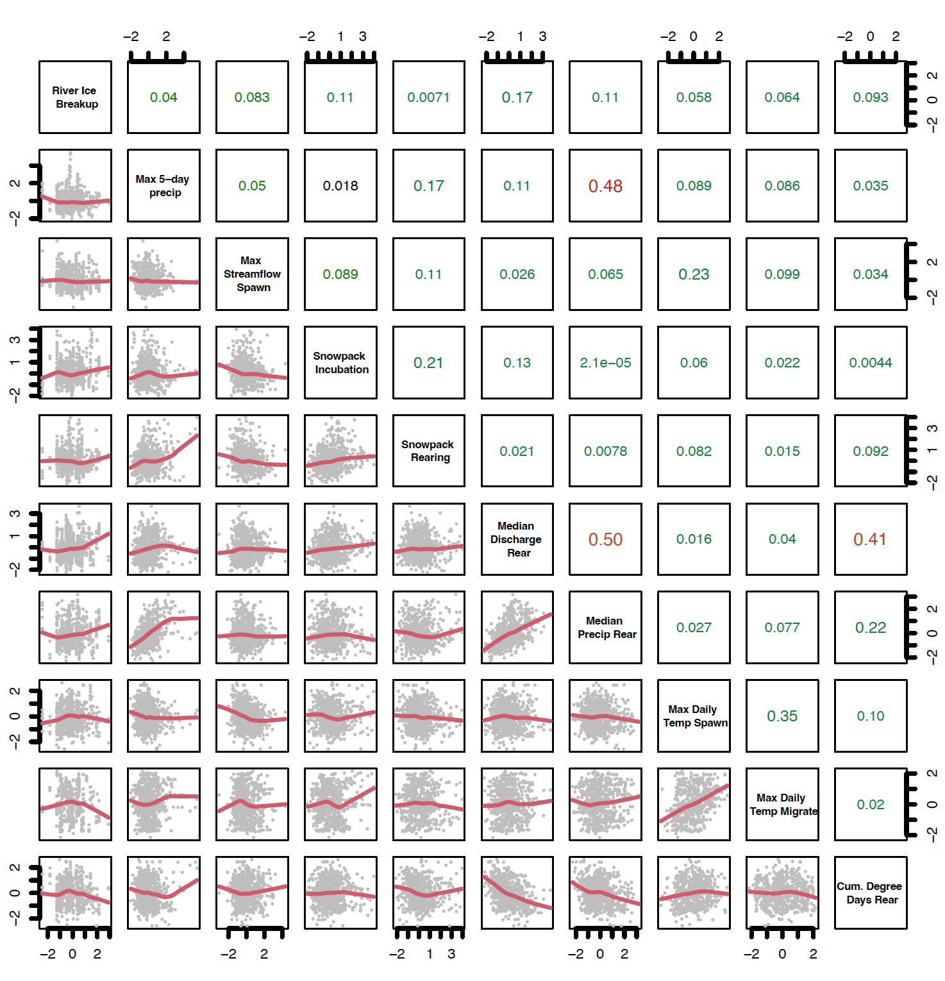

## Figure S14. Correlation Plot Candidate Freshwater Covariates

Correlation plot of the 10 candidate freshwater covariates that were considered for inclusion in the model. Some covariates characterize the same conditions (i.e., mean daily temperature during migration and mean weekly temperature during migration) even though only one was intended to be included in the model and both are represented in the correlation plot for comparison. See Table S4 for full description of the candidate covariates and Figure S16 for correlation plot of the covariate included in the final model. Correlation plot depicts lagged covariates.

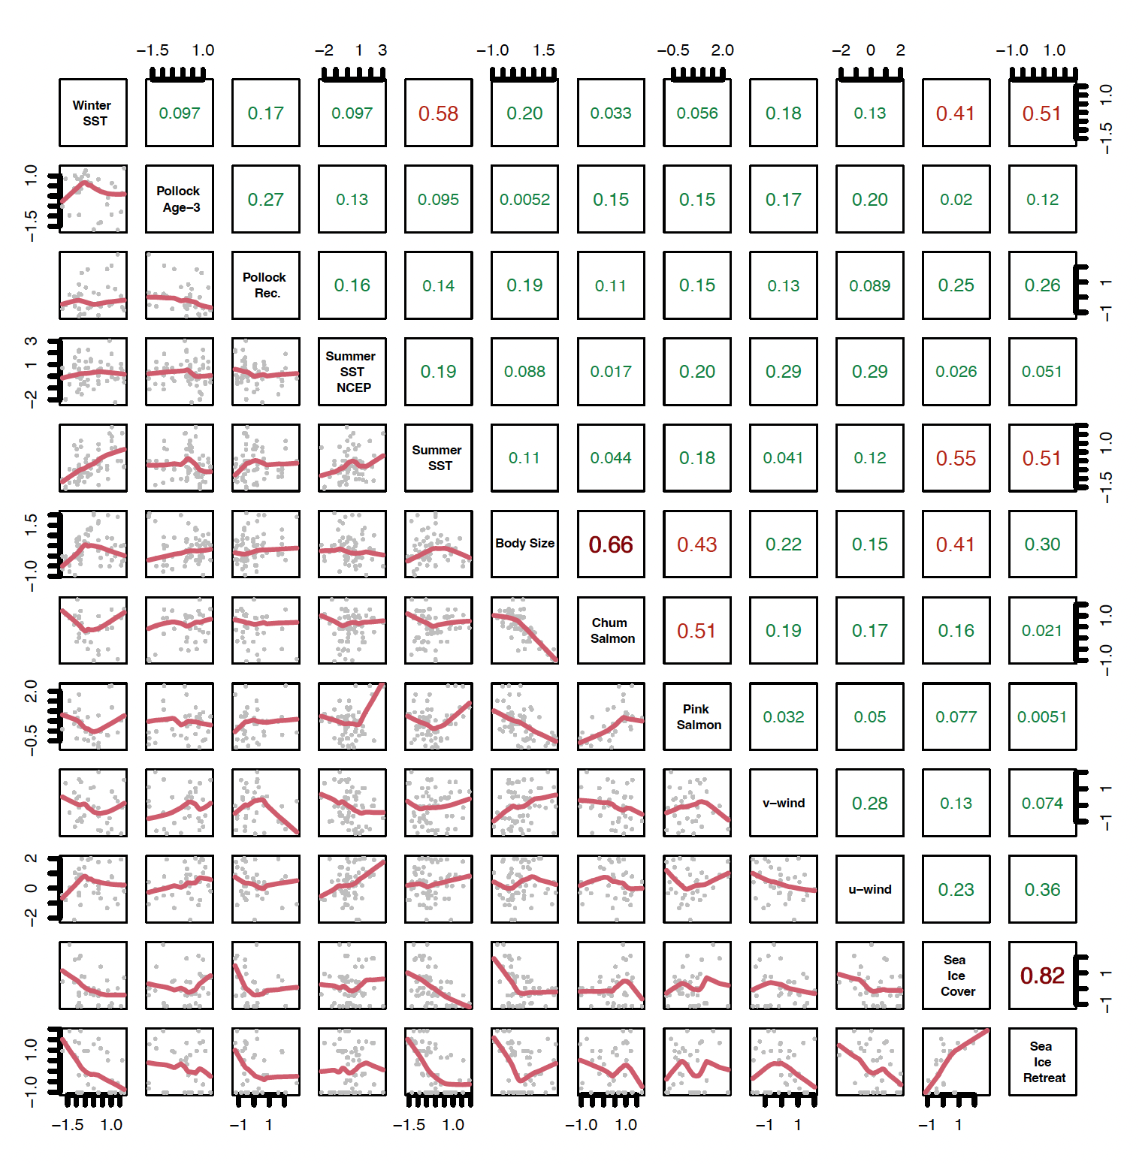

## Figure S15. Correlation Plot Candidate Marine Covariates

Correlation plot of the 12 candidate marine covariates that were considered for inclusion in the model. Some covariates characterize the same conditions using different datasets (i.e., Summer SST NCEP, Summer SST) even though only one was intended to be included in the model and both are represented in the correlation plot for comparison. See Table S4 for full description of the candidate covariates and Figure S16 for correlation plot of the covariate included in the final model. Correlation plot depicts lagged covariates.



## Figure S16. Correlation Plot Final Model Covariates (lagged)

Correlation plot of the 11 covariates that were included in the model; see Table S4 for full justification, data source, and hypotheses associated with each covariate. Correlation plot depicts lagged covariates. Correlation plot depicts lagged covariates.

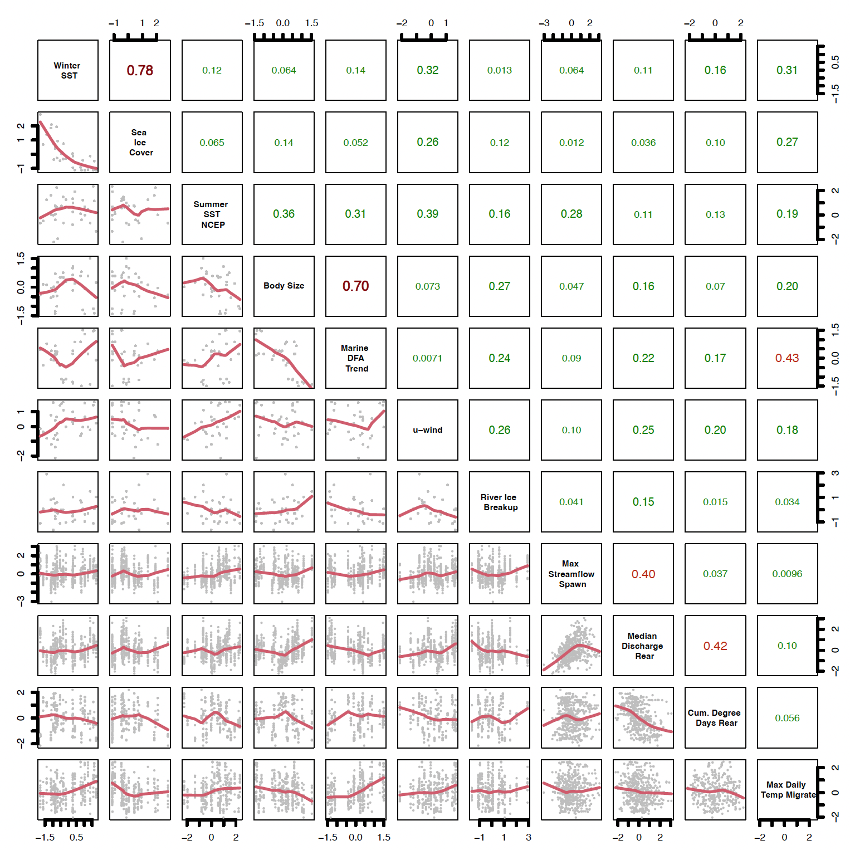

## Figure S17. Correlation Plot Final Model Covariates (unlagged)

Correlation plot of the 11 covariates that were included in the final model; see Table S4 for full justification, data source, and hypotheses associated with each covariate. Correlation plot depicts calendar year (non-lagged) covariates.

# **Appendix S6:** Model fits

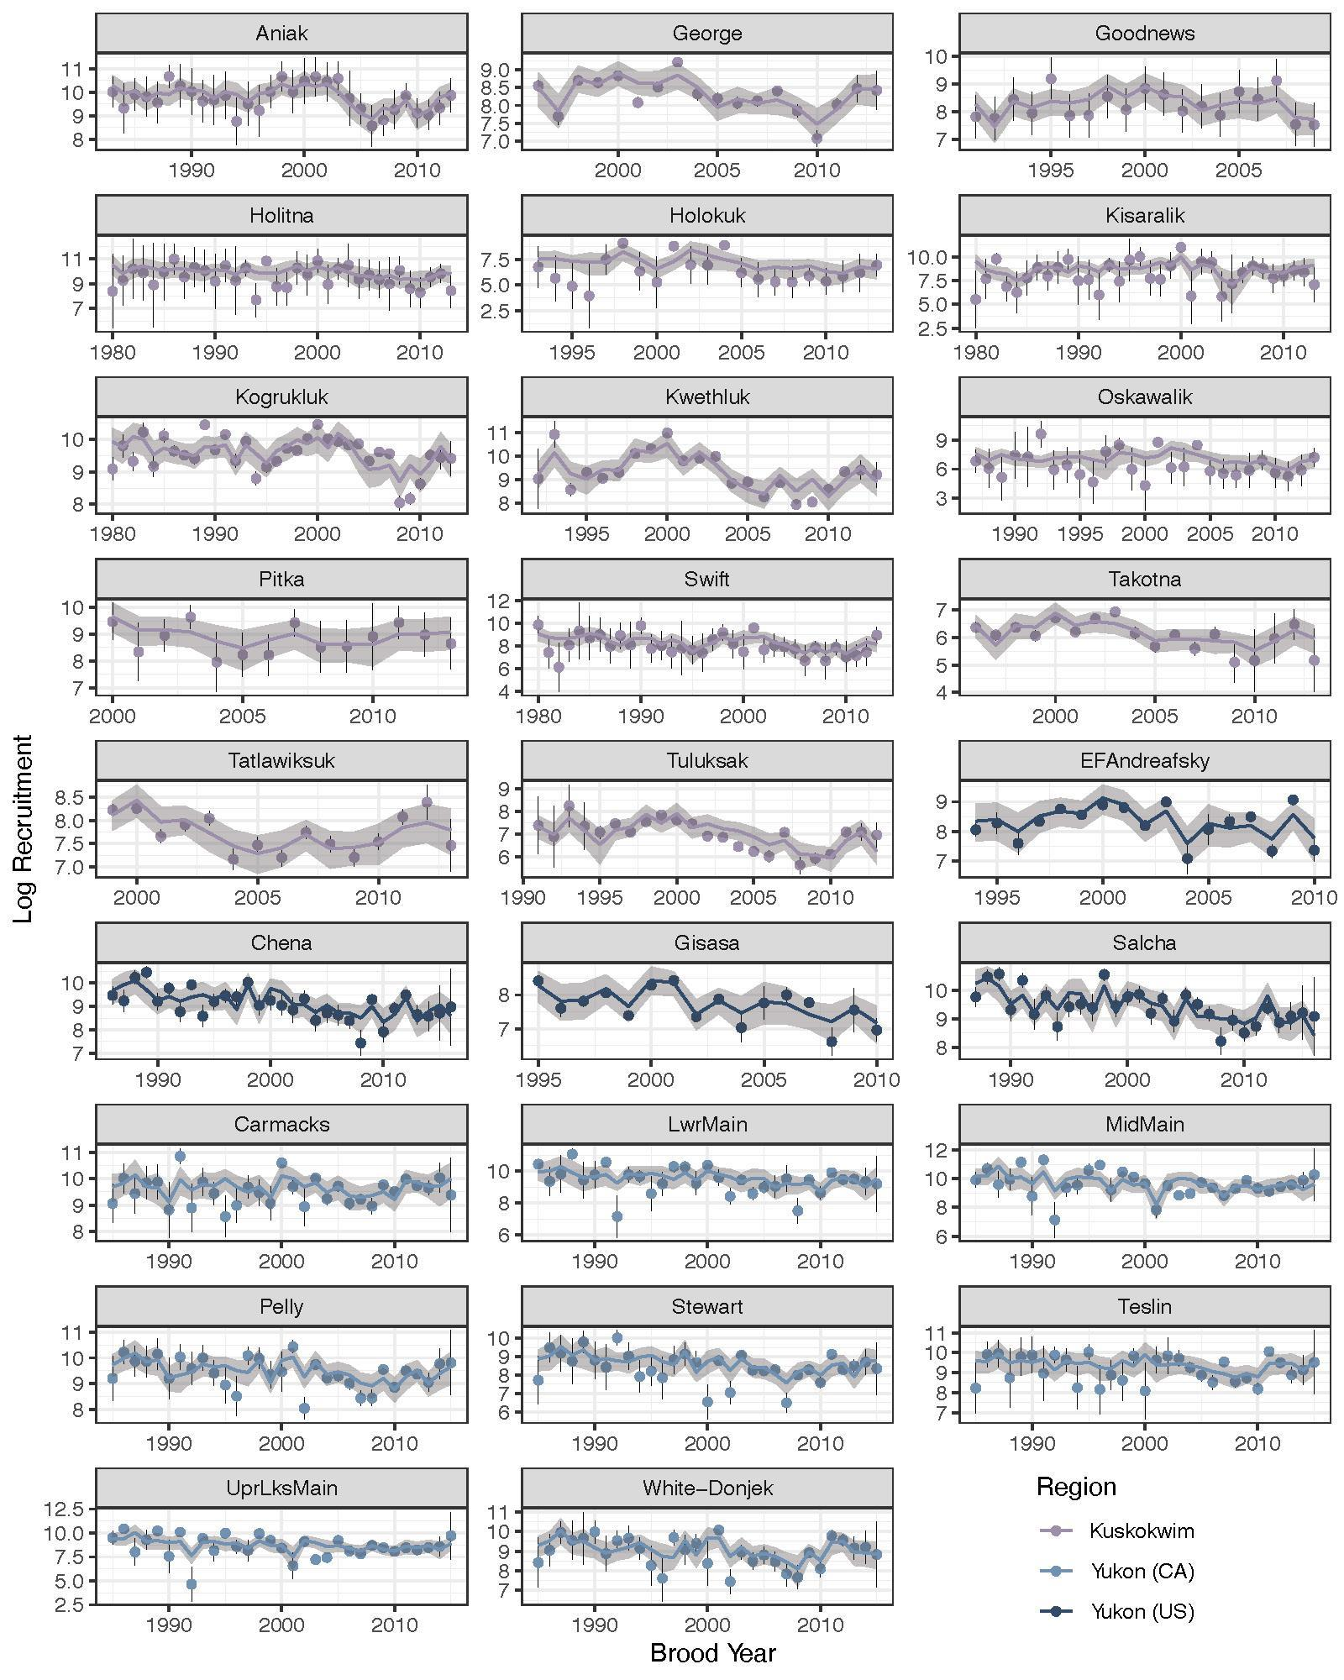

## Figure S18. Model Fits

Productivity model results for each Chinook salmon population. Colored points show the observed recruitment with the black line representing two standard deviations from the mean. The colored line represents the median of the posterior distribution estimated by the model with the shaded region representing the 95% credible intervals for predicted recruitment.

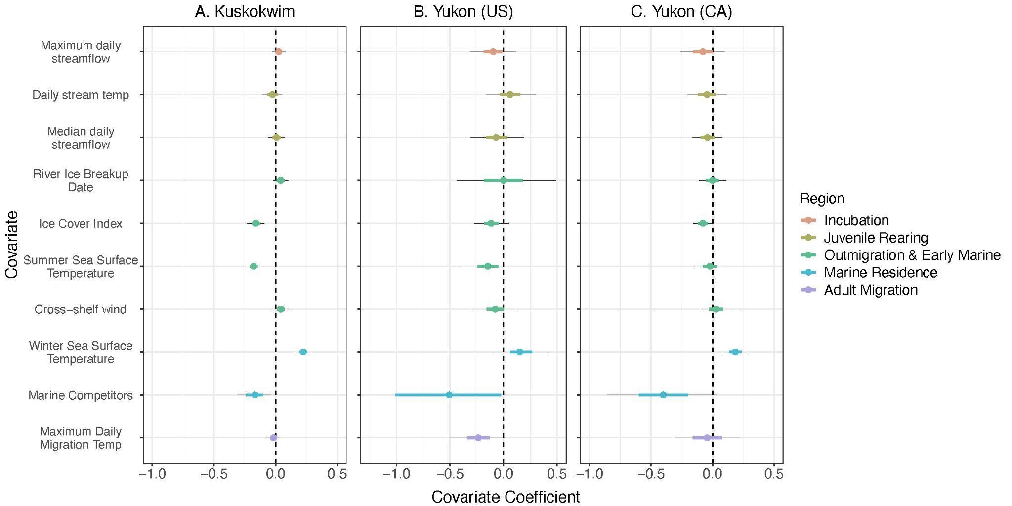

## Figure S19. Sensitivity Test for Body Size

Posterior estimates for regional mean effects of environmental covariates and on Chinook salmon population productivity (log recruits per spawner) with size omitted as a covariate for the three subregions: Kuskokwim (A), Yukon (US) (B) and Yukon (CA) (C) . Points describe the posterior median effect of each covariate on productivity, while the thick colored and thin black lines describe the uncertainty (50% and 80% credible intervals, respectively). Colors denote the life stage that the covariate impacts and the dashed line centered at zero represents a null effect on productivity. See Table [1](https://onlinelibrary.wiley.com/doi/full/10.1111/gcb.15155#gcb15155-tbl-0001) for description of covariates.

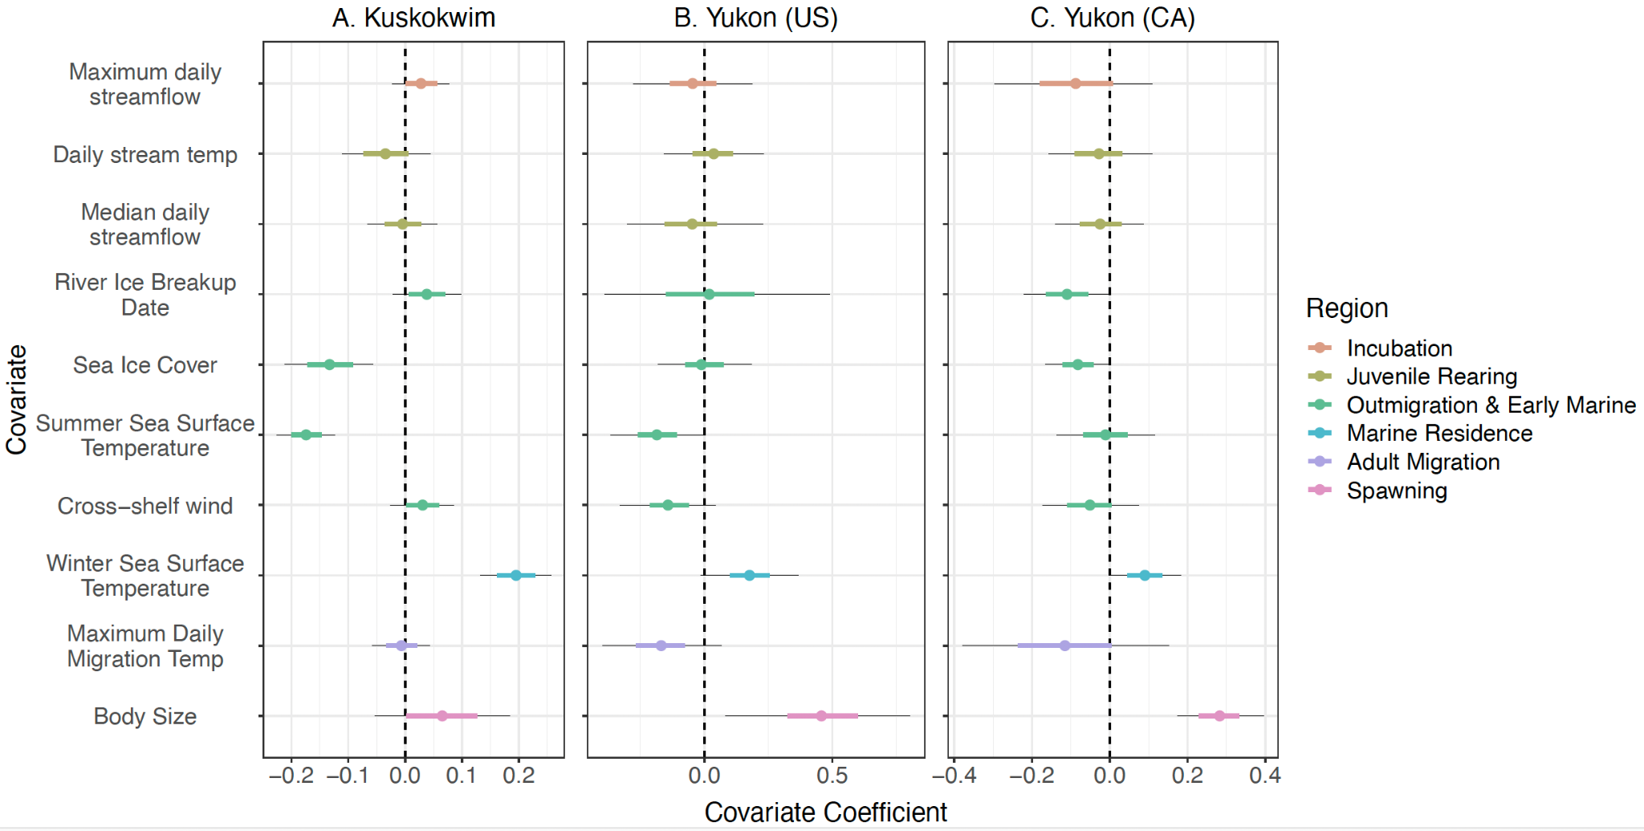

## Figure S20. Sensitivity Test for Marine Competitors

Posterior estimates for regional mean effects of environmental covariates and on Chinook salmon population productivity (log recruits per spawner) with marine competitors omitted as a covariate for the three subregions: Kuskokwim (A), Yukon (US) (B) and Yukon (CA) (C) . Points describe the posterior median effect of each covariate on productivity, while the thick colored and thin black lines describe the uncertainty (50% and 80% credible intervals, respectively). Colors denote the life stage that the covariate impacts and the dashed line centered at zero represents a null effect on productivity. See Table [1](https://onlinelibrary.wiley.com/doi/full/10.1111/gcb.15155#gcb15155-tbl-0001) for description of covariates.

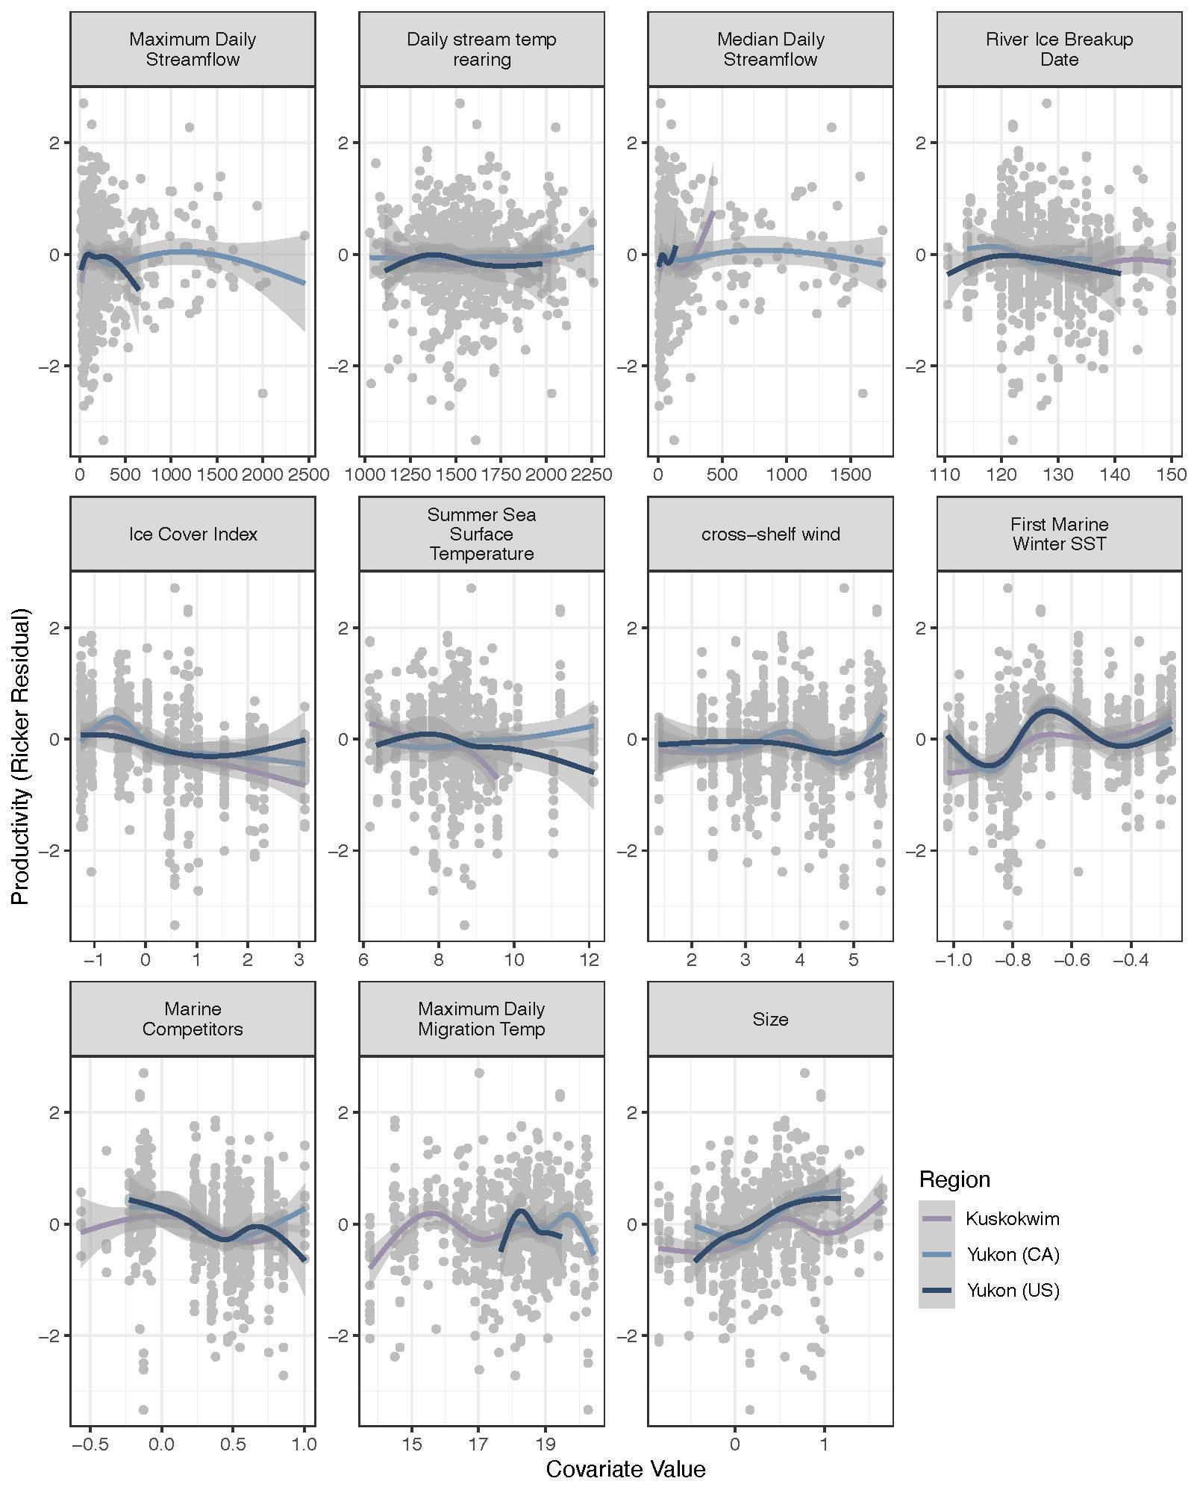

## Figure S21. Non-linear Test

Relationships between population productivity, and absolute values of covariates (compare to main text Figure 5). The vertical axis represents an index of population productivity after accounting for density dependence. Each circle represents the productivity of one population in one brood year, colored curves represent a LOESS fit to the data for each region, and the gray band represents the 95% confidence interval.